DRAFT
BIOENERGY VISION
FOR TASMANIA

contents

Introduction 3
Background 5
What is bioenergy? 5
Tasmania’s current bioenergy status 5
Potential for bioenergy in Tasmania 6
Tasmania’s bioenergy production potential 6
Tasmania’s bioenergy challenges 8
Benefits of developing Tasmania’s bioenergy sector 10
Renewable energy production 11
Reduction of greenhouse gas emissions 11
Waste management and resource recovery 13
Jobs and economic development 13
Consultation on draft Bioenergy Vision 15
The Government’s role 16
The role for industry and other levels of government 18
Have Your Say 19
How to make a submission 19
Timeline (Dates to be determined following final approval) 19
Support for the submission process 20
Appendix 21
Tasmanian Bioenergy Examples 21
Interstate Bioenergy Examples 22
Glossary 23
References 24

Introduction
Bioenergy is the largest source of renewable energy in the world and in Australia, where bioenergy produces more energy than all other sources of renewable energy combined (International Energy Agency (IEA) 2018).
The Government recognises the important role bioenergy could play in Tasmania’s energy systems and is committed to exploring opportunities in the State that will support an increased investment in bioenergy.
The Tasmanian Renewable Energy Action Plan (TREAP) sets out the Government’s commitment to develop a Bioenergy Vision, in consultation with industry and stakeholders, which will identify how the State can unlock private sector investment in bioenergy in Tasmania, increasing employment, reducing waste and greenhouse gas emissions while producing more Tasmanian renewable energy.
This draft Bioenergy Vision, including the below draft Vison statement, is an important step towards delivering against the commitment in the TREAP which has been developed based on consultation with industry and stakeholders and is now made available to all interested parties to provide feedback that will inform the final Vision.

The below draft Bioenergy Vision statement seeks to be an enduring vision encompassing all values impacted by bioenergy, relevant to all drivers for bioenergy development and scales of bioenergy application.
Draft Bioenergy Vision Statement:
To embed bioenergy as a valued renewable resource for the Tasmanian economy, community, and environment as an aid to energy production, waste management and resource recovery, and reduction of greenhouse gas emissions.
The draft Bioenergy Vision document sets out the importance of bioenergy from a Tasmanian context, with a focus on creating an environment that unlocks investment to deliver against the key drivers of bioenergy adoption, which are:
- Renewable energy production,
- Greenhouse gas emissions reduction,
- Waste management and resource recovery (supporting the circular economy), and
- Jobs and economic development.
The development of this draft Bioenergy Vision has been informed through consultation with an extensive range of stakeholders that represented: agriculture, aquaculture, waste management and resource recover, forestry and timber processing, power generation, industrial energy users, transport, peak industry bodies, construction, and government. The draft Bioenergy Vision for Tasmania has considered the maturity of the global bioenergy sector, research by experts such as Bioenergy Australia and the Australian Government’s National Bioenergy Roadmap (Roadmap).
The Tasmanian Government is committed to the development of a bioenergy sector that encompasses social, environmental, and economic values to achieve the best outcomes for Tasmanians. This includes a Government policy and regulatory framework to provide a foundation for long term investment in the sector and stimulate private investment in commercially and environmentally sustainable bioenergy projects.
The release of the draft Bioenergy Vision publicly provides the opportunity for all Tasmanians to shape the final Vision and the Government’s role in achieving the vision.
We encourage submissions and provide a series of questions under the “Have your Say” section at the end of this document to prompt discussion and feedback.

Background
What is bioenergy?
Bioenergy is energy produced from organic matter. It can be produced from almost any organic matter of agricultural, industrial, municipal and forestry origin. Organic waste and residues sourced from agriculture, municipal and forestry activities such as crop wastes and remains, manures and sludges, rendered animal fats, used oils, food and garden organic waste, timber harvesting and processing residues, construction and demolition woody waste and residual municipal solid waste are known collectively as “biomass” and can be used as feedstock for bioenergy production.
Bioenergy can produce a wide variety of energy outputs, including electricity, heat, fuels such as methane, and transport fuels for cars, boats, and planes. As biomass can be regrown sustainably, bioenergy is globally recognised as a renewable energy. It can displace fossil fuels in almost every market and reduce greenhouse gas emissions. A bioenergy facility can produce a variety of energy sources, including:

- liquid fuel from used cooking oil and forest harvest and processing residues;
- gas for heating and power from poultry farms, animal manures, brewery sludges, and dairy and meat processing waste;
- heat and cooling from municipal waste and agriculture and timber industry residues; and
- power from all of the above waste materials, including base-load power.
Tasmania’s current bioenergy status
The most common application of bioenergy in Tasmania is the use of wood to heat homes where approximately one quarter of Tasmanian households primarily relying on this type of heating.

There are also industrial scale examples of bioenergy in Tasmania, including 10 industrial scale boilers or kilns that combust sawmill residues or woodchips. These boilers and kilns are used to dry sawn wood, fire bricks, cook vegetables, heat greenhouses for vegetable, flower, and nursery production, provide heat to a meat processor and heat water and spaces in a sports complex. In most cases the boiler or kiln was installed because it was the cheapest source of heat energy available, but for sawmills they also provide a convenient way of disposing of timber processing wastes. Other businesses intentionally use wood waste and residues to reduce their greenhouse gas emissions from the combustion of fossil fuels.

There are 13 industrial scale anaerobic digesters in Tasmania that are used to treat sewage, as well as organic-rich liquid wastes from meat processors, a brewery, a dairy processor, and a chocolate manufacturer. The process of anaerobic digestion converts organic matter into biogas (methane and other gasses) which can be used to produce heat for industrial processes, accelerate sewage decomposition, or simply flared to the atmosphere. The predominant driver for the adoption of anaerobic digestion technologies was to reduce waste management costs. Other drivers included reducing energy costs and lowering greenhouse gas emissions. More detailed examples of bioenergy facilities operating in Tasmania and interstate can be found in the Appendix.
Potential for bioenergy in Tasmania
Tasmania’s bioenergy production potential
Tasmania produces large quantities of various organic waste and residues that could be used to produce a wide range of energy types. The Australian Biomass for Bioenergy Assessment (ABBA) Project funded by the Australian and Tasmanian Governments recently found that Tasmania annually produces 7.8 million tonnes of liquid organic waste and 1.4 million tonnes of solid organic waste from municipal, agricultural, forestry and industrial sources (Figure 1).

Figure 1. Quantities of organic waste that may be made available for bioenergy production annually in Tasmania (2016)

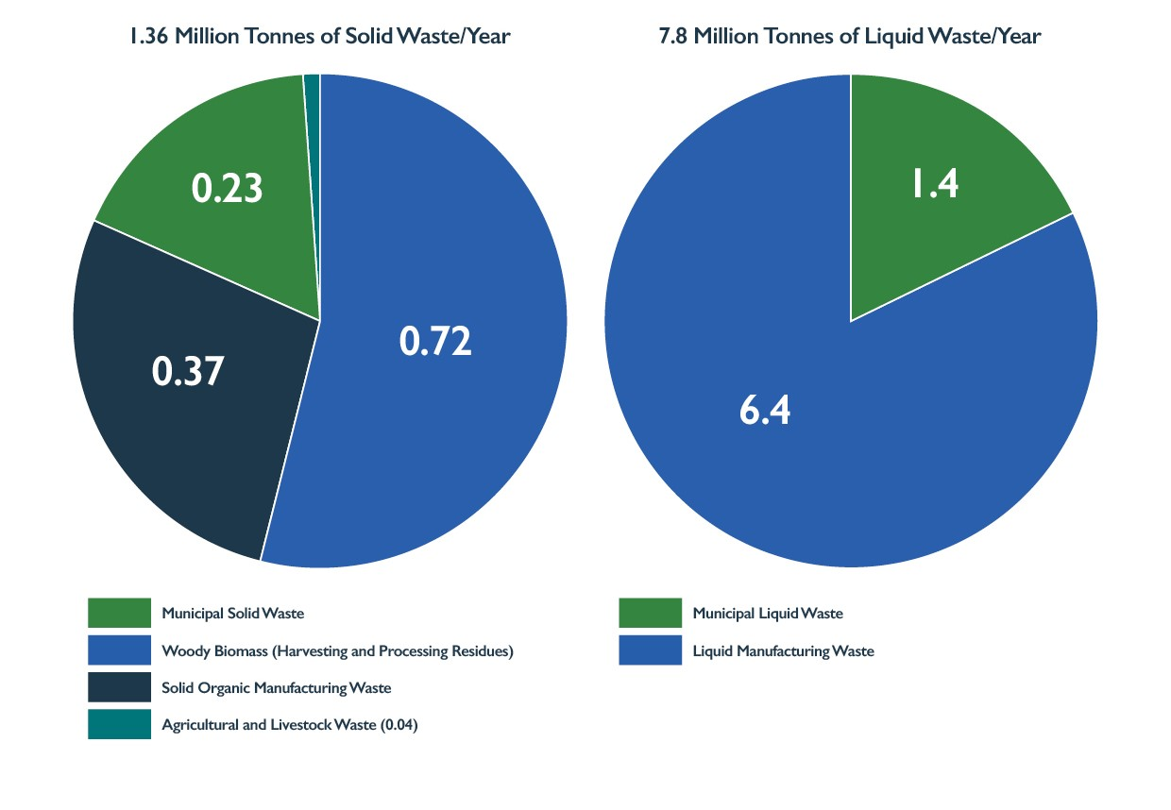

There is an opportunity for some of Tasmania’s energy market to be supplied by bioenergy. This includes new energy generation and for bioenergy to displace fossil fuel use and reduce greenhouse gas emissions.

Bioenergy in the form of biofuels could potentially displace some of the almost 1 billion litres of transport fuel sold in Tasmania each year (Figure 2). Biogas could also displace a proportion of the 7-15 thousand terajoules (TJ) of energy consumed as natural gas from the Tasmanian Gas Pipeline (TGP) to Tasmanian or sold to interstate customers through the TGP.

While Tasmania is now 100 per cent net self-sufficient in renewable electricity, additional renewable electricity could be used behind the meter to reduce electricity costs or be sold interstate via Basslink.
Figure 2. Existing Tasmanian energy markets (2019-2020)

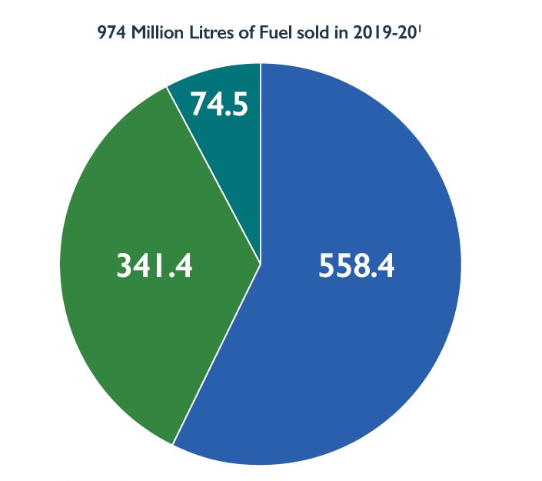

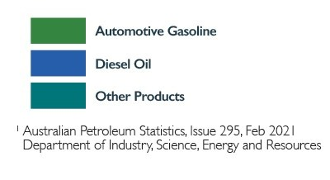

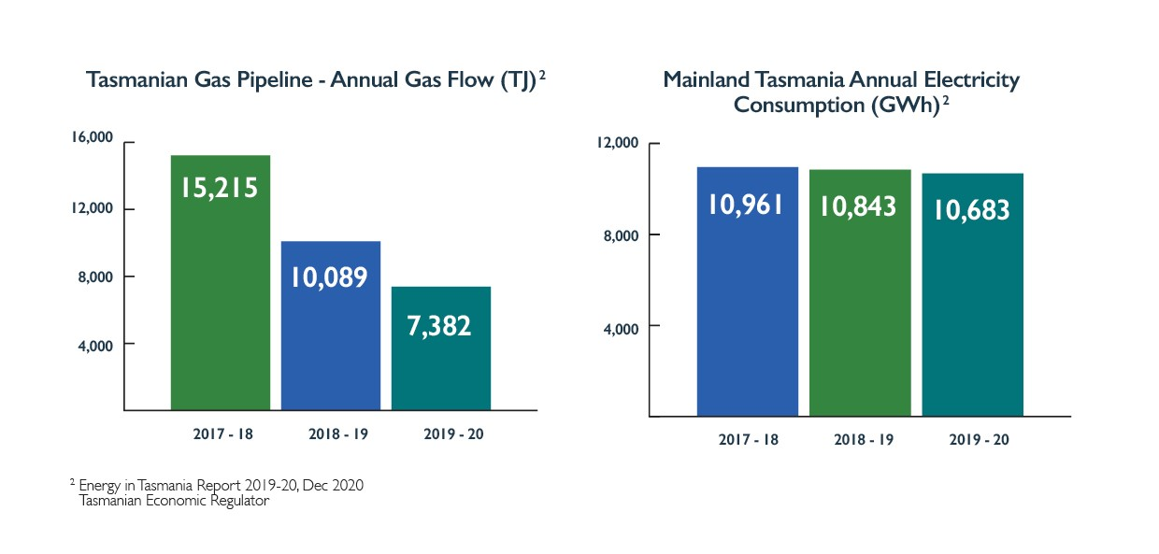

Tasmania’s bioenergy challenges
Tasmania and Australia lag many other nations in the uptake of bioenergy (O’Hara et al. 2018), despite having large quantities of waste and residue organic streams and strong demand for energy that could be produced by bioenergy.

Anecdotally, there is currently a lack of knowledge and familiarity with bioenergy in Tasmania. This may attribute to why bioenergy is often not considered, or is considered too risky, for applications such as;

- a renewable energy source;
- a waste solution;
- an approach to reduce greenhouse gas emissions; or to
- stimulate regional employment and economic development.
Furthermore, while bioenergy is associated with social and environmental benefits, there are also social and environmental challenges that must be addressed.

Few bioenergy technology providers have permanent representatives in Tasmania and the few industrial-scale bioenergy facilities installed in Tasmanian businesses are not well known or publicised. In addition, not all forms of bioenergy currently exist in Tasmania. For example, there are no Tasmanian enterprises using biomass to produce combined heat and power, transport fuels, or biogas for injection into the gas grid. Greenhouse gas abatement was not a key driver for the establishment of most bioenergy facilities, and none were explicitly established to stimulate regional employment and economic development.

Bioenergy facilities are long term investments that require long term energy offtake and feedstock supply agreements and confidence that facilities can operate for long time horizons to achieve a return on investment. In addition, they are often more complicated and expensive to install and maintain, require a larger footprint and specialised knowledge of the technology and its benefits to enable successful deployment.

Biomass feedstocks used in the production of bioenergy are often bulkier more dispersed and variable in quality than alternative fuels necessitating more complex supply chains to gather, transport, store and deliver the feedstock to bioenergy facilities. Consequently, bioenergy feedstock supply agreements and supply chains can be complex and difficult to establish. While feedstock supply chains exist in Tasmania, the lack of specifications for the feedstock quality, and variability in the quality of the fuel currently delivered has potentially deterred investment in bioenergy facilities.

In some instances, older bioenergy facilities have been associated with smoke production, particulate emissions and smells that have given the technology a poor reputation.

The above challenges are not insurmountable, but practical solutions may not be widely known due to the limited uptake and knowledge of bioenergy technologies in the Australian market. The higher establishment costs of bioenergy facilities are often offset by lower fuel and reduced waste management costs that can make bioenergy the cheapest energy source when a full life-cycle analysis is conducted. Moreover, modern bioenergy facilities continue to be installed and operated in many developed countries in compliance with strict environmental standards.

It is also important to recognise that not all biomass is appropriate for bioenergy production. Some biomass can and should be reused, recycled, used to produce higher value products, or left in the landscape to preserve environmental values. Producing bioenergy from higher value products such as food crops and high value wood, or native vegetation harvested solely for bioenergy production is unlikely to be economically, socially, or environmentally sound. Without significant subsidies, it is unlikely that bioenergy facilities in Tasmania could pay enough for biomass to compete with industries capable of adding value to the same resource or justify expenses of harvesting vegetation solely for bioenergy production. The harvesting of native forests specifically for renewable energy production is not currently required or anticipated to be a part of the Tasmanian Renewable Energy Target (TRET). The focus of the Tasmanian Bioenergy Vision is therefore on the utilisation of organic waste and residue streams.

Benefits of developing Tasmania’s bioenergy sector
The development of a bioenergy sector will need to encompass social, environmental, and economic values to achieve the best outcomes for Tasmanians. This includes a Government policy and regulatory framework to provide a foundation for long term investment in the sector and stimulate private investment in commercially and environmentally sustainable bioenergy projects.

The draft Bioenergy Vision recognises four key drivers for the adoption of bioenergy. Bioenergy is differentiated from most other energy sources in that it can deliver solutions for these drivers simultaneously.

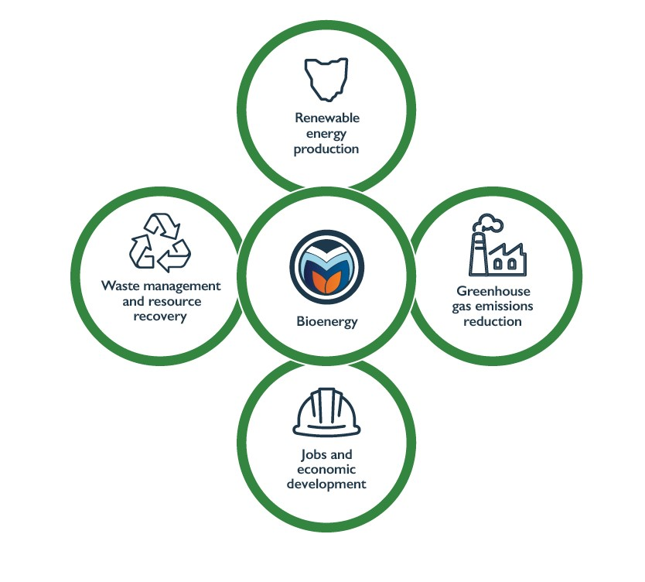

Renewable energy production
The Tasmanian Government has identified renewable energy as a key economic driver. The TREAP sets out the pathway to deliver on the Government’s vision of utilising renewable energy to benefit all Tasmanians through job creation, helping our environment and driving investment and economic growth. The TREAP recognises bioenergy as one of the renewable energy sources that can contribute to these priorities.

Bioenergy can generate many forms of energy from various organic feedstocks by using a range of technologies (Figure 4).

Figure 4. Bioenergy products, converstion technologies and feedstocks
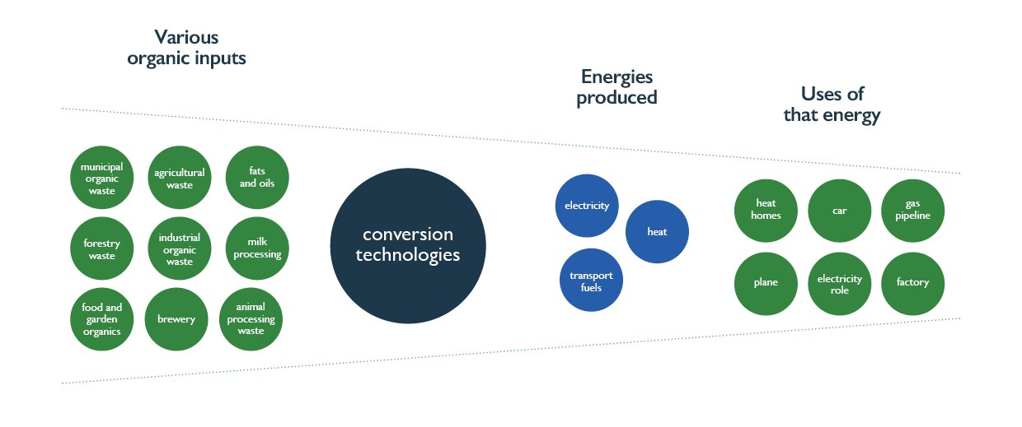
Globally, approximately half the total renewable energy consumed in 2017 was generated by modern bioenergy technologies according to IEA (2018). The IEA identified bioenergy as the overlooked giant of renewables with its growth expected to be higher than other renewables for the near future.

In 2017-18 bioenergy produced 52 per cent of Australia’s renewable energy consumption (Department of Industry, Science, Energy and Resources 2020). The major sources of bioenergy generation were from sulphate lyes, woody biomass and bagasse with minor bioenergy generation from municipal and industrial waste, and from the consumption of biogas and transport fuels made from biomass.
Since biofuels are often produced locally, bioenergy use could improve Tasmania’s fuel security by reducing reliance on imported fuels, including fossil fuels.
Reduction of greenhouse gas emissions
The carbon released from using biomass fuels is reabsorbed as biomass regrows making bioenergy a source of renewable energy with low greenhouse gas emissions (Figure 5). Greenhouse gas emissions can be reduced when bioenergy displaces fossil fuels. Bioenergy is one of the few renewable energy sources that can displace fossil fuels in almost every energy market.
The Intergovernmental Panel on Climate Change (IPCC) and the IEA identify a key role for bioenergy to achieve the Paris Agreement, which aims to keep the global temperature rise well below 2˚C (IPCC; IEA 2017) and in pathways that limit global warming to 1.5˚C (IPCC 2018).

The Australian Government recognises the emissions reduction potential of bioenergy through the work of the Australian Renewable Energy Agency (ARENA), the Clean Energy Finance Corporation (CEFC) and the Australian Clean Energy Regulator (ACER).

The Tasmanian Government is committed to reduce greenhouse gas emissions set out in the Climate Change (State Action) Act 2008 (the Act) and the Government’s current Climate Change Action Plan (Climate Action 21). The next whole-of-government climate change action plan is under development and will build on the priority areas of the current plan.

The Government has recently announced its intention to legislate a target of net zero emissions from 2030. The target was recommended as part of the Independent Review of the Act and supported by Tasmania’s Emissions Pathway Review and a detailed economic analysis of the impact on jobs, industry, and growth. This target will be nation-leading and one of the most ambitious in the world.

The independent Review of the Act also identified bioenergy’s potential to reduce emission from industrial manufacturing and processing by replacing fossil fuels used for high temperature process heat.

Clearly, the emissions reductions and renewable energy generation potential of bioenergy support the above policies and initiatives.
Figure 5. Biomass for bioenergy carbon cycle.
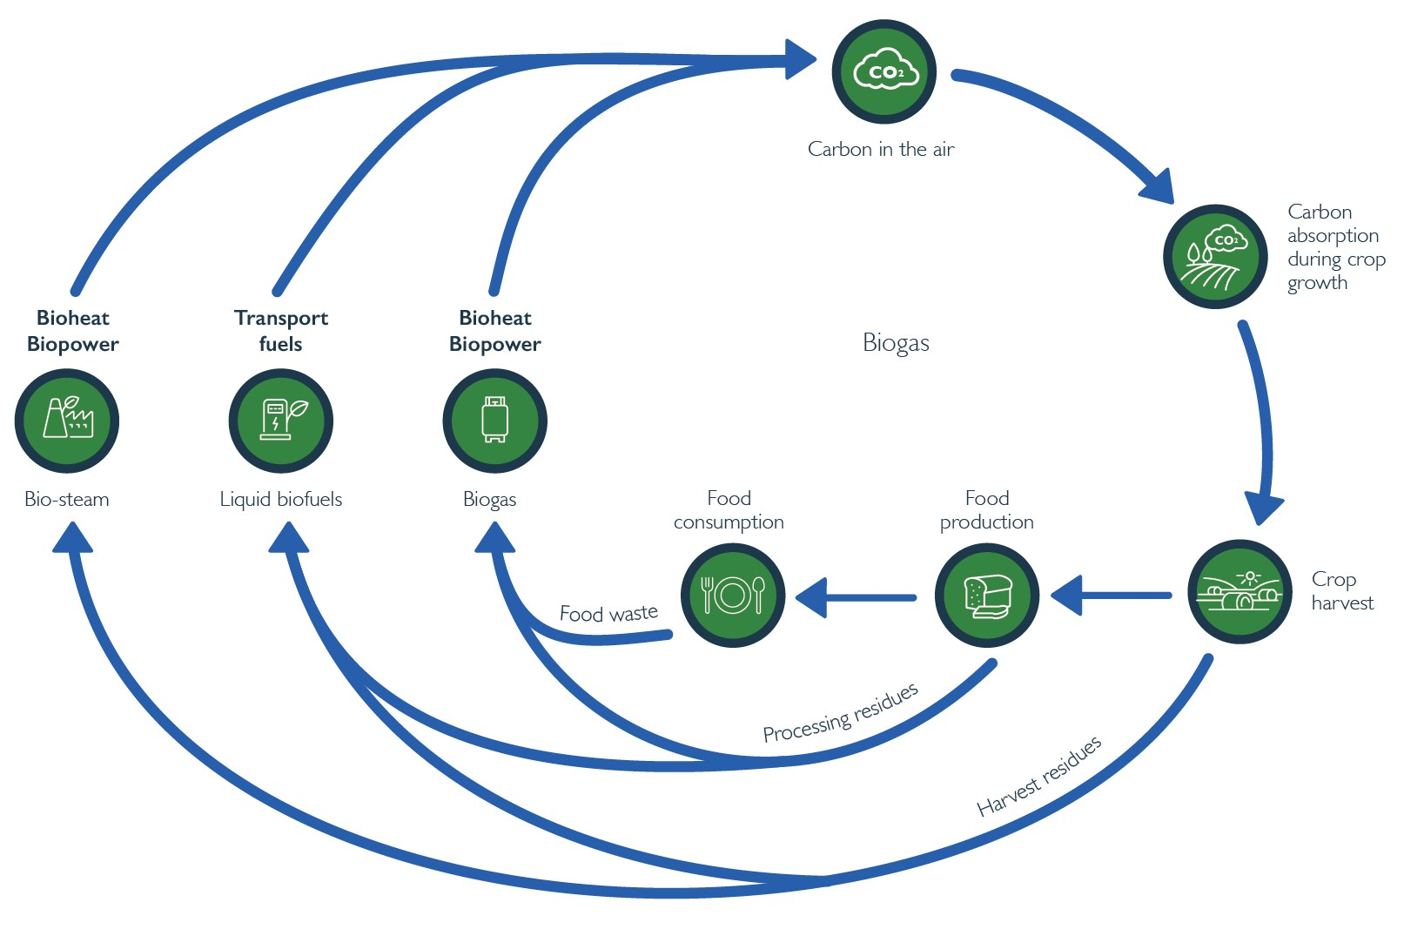
Waste management and resource recovery
Biomass is consumed to produce energy at bioenergy facilities. Bioenergy facilities can consume organic waste and residue streams that arise from agricultural activities, including crop harvesting and processing residues, municipal sources such as food and garden organics, residual municipal solid waste, and woody waste from construction and demolition sources and forest harvesting and processing waste and residue streams.

Without appropriate management, waste and residue streams can accumulate in businesses and the environment, creating potential hazards to public health and safety, including pollution and increased fire risks. The management, processing and disposal of waste often comes at a significant cost to businesses and society.

Efforts to address waste include producing less waste, greater resource recovery and re-use, and reducing the amount of organic waste going to landfill. These practices are consistent with the 2018 National Waste Policy and the Tasmanian Draft Waste Action Plan and more broadly, with the circular economy principles.

A circular economy is an economy that is structured to maximise the use and value obtained from materials and resources at every stage of the life of a product or material. The principles of the waste hierarchy that focus on waste prevention are an essential component of how we manage waste and resource recovery in a circular economy. Waste prevention principles ensure we design out waste, and prioritise resource recovery, repurposing, and recycling.

Moving towards a circular economy while applying the waste hierarchy is expected to reduce waste, promote innovation and a more creative, robust, and productive economy. Bioenergy should foster and not prevent waste reduction, recovery, repurposing, and recycling enabling the “highest value” should be sought for organic material. However, when organic material reaches end of life one of its valuable uses can be to provide energy to society.

Waste and residue streams that do not have alternative higher-value markets in the circular and bio economies, or that reach end of life can be used to generate bioenergy. Further, bioenergy facilities can also play a role in aggregating organic material, facilitating reuse and recycling with those higher-value uses in mind, and with the high-value products made using bioenergy. In the current environment there are many opportunities to use waste organic material for bioenergy, as it provides a higher outcome than the disposal and current practices for many waste streams and the quantities of waste streams will allow the bioeconomy and bioenergy to coexist.

The Tasmanian Government is implementing a waste levy as part of its 2019 Waste Action Plan to encourage the diversion of waste biomass from landfill to alternative uses including bioenergy generation.
Jobs and economic development
Bioenergy can contribute to regional economic development through the local production of fuels which can substitute for imported fuels and ensure that a larger proportion of expenditure on fuels is retained in the local community. Bioenergy also requires more complex feedstock collection and handling supply-chains and equipment than most alternative forms of energy generation, providing significant opportunities for employment, especially in rural and regional areas where most of the feedstock tends to be located.

Businesses supplying organic waste and residues, including industries processing organic feedstocks and agricultural and forestry enterprises can become more competitive by reducing waste costs and through more efficient utilisation of harvested products. Bioenergy provides opportunities to reduce waste management costs or even turn a waste stream into a viable commodity, which supports the Governments objectives to grow the agricultural and forestry sectors.

Bioenergy can contribute to the Tasmanian Sustainable Agri-Food Plan 2019-23 by reducing waste and turning waste into an energy commodity increasing returns to the sector, assisting Tasmania in achieving its goal of increasing the value of the agricultural sector to $10 billion by 2050 and making agriculture more sustainable. Bioenergy could play a critical role in supporting the Competitiveness of Tasmanian Agriculture for 2050 White Paper which highlights circular economy principles and value adding as one of three priority areas for agriculture.

Bioenergy supports the Strategic Growth Plan for the Tasmanian Forests, Fine Timbers and Wood Fibre Industry (2017) by assisting to secure a profitable use for harvest and processing residues. Using bioenergy to turn waste and residue into a commodity will improve the long-term competitiveness and income generation of the sector. Furthermore the 2017 Tasmanian Wood Encouragement Policy supports renewable energy production from wood.

Since bioenergy can be rapidly rolled out, bioenergy supports the regional employment and economic development that can assist the Premier’s Economic and Social Recovery Advisory Council (PESRAC) objectives for Covid-19 recovery.

Employment benefits associated with bioenergy has been observed by the IEA which reviews renewable energy and associated jobs on an annual basis. Their 2020 review reports the global employment in the global bioenergy sector has substantially grown in the last few years, achieving 3.58 million jobs in 2019.

Producing transport fuels provide further examples of the potential for bioenergy to provide jobs and grow the economy. The Queensland University of Technology report “Biofuels to bioproducts: a growth industry for Australia” described how increased use of 10 per cent ethanol‐blended petrol (E10) in Australia could create 2 080 direct jobs and up to 6 570 indirect jobs, potentially attracting A$1.56 billion of investment and generating more than A$1.1 billion of additional revenue per year in regional communities. According to the ARENA and CEFC report “Biofuels and Transport: An Australian opportunity”, an Australian biofuels production target of 20 gigalitres per year could provide long-term employment for up to 250,000 people, mostly in regional areas.

Consultation on draft Bioenergy Vision
The draft Bioenergy Vision was developed in consultation with an extensive range of stakeholders that represented agriculture, aquaculture, waste management, forestry and timber processing, power generation, industrial energy users, transport, peak industry bodies, construction, and government provided the below suggestions to accelerate the appropriate adoption of bioenergy in Tasmania.

- Bioenergy will benefit from a greater community and business understanding and support for bioenergy, including for all drivers.
- There are many current opportunities for bioenergy in Tasmania that can quickly be realised. Key opportunities exist to produce energy for industrial applications, especially heat, and to provide waste management solutions. There was also interest in reducing greenhouse gas emission by using transport biofuels.
- Realising current opportunities for bioenergy can be facilitated by the Tasmanian Government bringing together businesses, councils, and other participants in the bioenergy supply chain to overcome issues of scale, coordination, standards, and specifications.
- Government policy and incentives for bioenergy should be explored to remove barriers, encourage appropriate investment, and provide a stable long-term investment environment for bioenergy.
- As current opportunities are realised and confidence in bioenergy grows in Tasmania, the adoption of more sophisticated examples that are being deployed around the world will become more likely.
The Government’s role
To achieve the draft Bioenergy Vision, the Tasmanian Government is demonstrating its commitment to the Tasmanian Renewable Energy Action Plan and bioenergy by committing $100 000 to explore where renewable energy, including bioenergy, can displace fossil fuels used to provide heat to Government buildings in Government owned boilers. Government procurement is potentially able to promote bioenergy in relevant infrastructure project, building familiarity with bioenergy technology adoption processes in Tasmania. This is an important practical step to investigate how to reduce greenhouse gas emissions in Government buildings and support the adoption of bioenergy in Tasmania.

Other roles for the Government include:

- Building industry and community awareness of bioenergy.
The Government could make information on bioenergy publicly available including compiling information on organic waste and residue streams potential available as bioenergy feedstocks in Tasmania, the types of energy that could be produced from them, and the outcomes that could be simultaneously achieved through the adoption of appropriate bioenergy technologies.

The Government could also play a role in raising awareness of bioenergy options and the benefits of bioenergy among councils, industry bodies, businesses, and community organisations. This could include developing case studies highlighting successful Tasmanian and Australian bioenergy initiatives and supporting organisations wishing to emulate these examples or investigate other bioenergy options.

- Explore private sector opportunities to deploy bioenergy in Tasmania.
The Government could play a facilitation and coordination role, in collaboration with councils and the business community, to:

- Promote the aggregation of biomass from different business and council sources to achieve economies of scale in the supply of organic waste and residues streams suitable for bioenergy production;
- Help organisations with the potential to produce bioenergy from organic waste and residue streams to find markets for their surplus bioenergy or bioenergy production capacity; and
- Assist the market to overcome challenges with organic feedstock quality and consistency.

- Developing a more sophisticated, mature, and diverse bioenergy industry in Tasmania.
The Government could build on existing investment attraction and industry development efforts by promoting Tasmania’s potential bioenergy resource and options to prospective local, interstate, and international investors.

Bioenergy has the potential to attract businesses to the State and can provide the business with a marketing advantage through realising the benefits from the four drivers of bioenergy.

- Ensure Tasmanian has an enabling regulatory and operating environment to support a larger bioenergy industry.
The Government could coordinate across relevant policy areas to minimise obstacles to the deployment of bioenergy in Tasmania and optimise economic, social, and environmental outcomes for the State from bioenergy.

The Government could also cooperate with the Australian Government and other state and territory Governments to identify, develop, and implement best practices to accelerate the adoption of bioenergy in Tasmania.

The role for industry and other levels of government
The many benefits of bioenergy will only be fully realised when industry, councils, businesses, and the public consider and adopt bioenergy where it is appropriate and offers the best outcomes.

For many industry participants, the adoption of bioenergy will already make economic and environmental sense where it provides low-cost energy and waste management solutions, including reducing greenhouse gas emissions. The bioenergy examples in the Appendix show how a range of business have already successfully adopted bioenergy achieving these outcomes as well as supporting regional employment.

Tasmanian councils have already adopted bioenergy solutions to help them better manage landfill gases and reduce greenhouse gas emissions and heat facilities. Local councils can play an important role in facilitating bioenergy projects by promoting bioenergy, adopting bioenergy where appropriate, and assisting with the aggregation of waste organic streams and linking the energy production potential of bioenergy with energy users suited to bioenergy.

Have Your Say
How to make a submission
The Tasmanian Government is committed to providing opportunities for community involvement in the development of Government policy and we are seeking your input on the Draft Bioenergy Vision.

All submissions on the Draft Bioenergy Vision must be received by 5pm on 14 February 2022.

Submissions can be sent by:

Email: bioenergy@treasury.tas.gov.au
Mail: GPO Box 147, Hobart TAS 7001 (Attention: ReCFIT – Bioenergy)

Other than indicated below, submissions will be treated as public information and will be published on our website at www.ReCFIT.tas.gov.au/consultation

No personal information other than an individual’s name or the organisation making a submission will be published unless you request otherwise.

If you would like your submission treated as confidential, whether in whole or in part, please indicate this in writing at the time of making your submission clearly identifying the parts of your submission you want to remain confidential and the reasons why. In this case, your submission will not be published to the extent of that request.

Copyright in submissions remains with the author(s), not with the Tasmanian Government.
The Department will not publish, in whole or in part, submissions containing defamatory or offensive material. If your submission includes information that could enable the identification of other individuals, then either all or parts of the submission will not be published.

Timeline
- Draft Bioenergy Vision is made available for consultation 15 December 2021
- Submissions on Draft Bioenergy Vision close 14 February 2022
- Finalised Draft Bioenergy Vision provided to the Tasmanian Government for consideration

Support for the submission process
We welcome your feedback on developing a bioenergy sector in Tasmania. We have included some questions that may assist in preparing your submission.

Questions to consider
- What changes, if any, would you suggest to the draft Bioenergy Vision?
- What are the key roles for the Tasmanian government to support bioenergy?
- What are the key roles for households, industry, and other levels of government to support bioenergy?
- What do you think could be done to appropriately accelerate the uptake of bioenergy in Tasmania?
- What are the key opportunities for bioenergy in Tasmania? What can be done to realise these opportunities?
- What are the key challenges for bioenergy in Tasmania? What solutions do you see for these challenges?

Appendix
Tasmanian Bioenergy Examples
Austral Bricks (Longford)
This facility produced the world’s first certified carbon neutral bricks. Sawdust displaced diesel to fire their brick making kilns in the 1980s, though the kiln still required some oil and diesel fuel. In 2012 the plant was connected to LPG and Austral Bricks had the choice to convert to LPG or fully convert to sawdust. In 2012 Austral Bricks decided to fully convert to sawdust and undertake energy efficiency project in the plant and go for carbon neutral certification. In 2013 Austral Bricks estimated it had reduced carbon emissions by 8 392 tonnes of CO₂ equivalents per year. The conversion to bioenergy lowered fuel costs, sawdust is cheaper than fossil fuels, even though there were some additional costs to handle the sawdust. After the conversation architects generated demand for the carbon neutral bricks for sustainable developments including for the construction of net zero greenhouse gas emission buildings. Production of carbon neutral bricks in Longford help Austral Bricks achieve sustainability goals and shareholder commitments. Furthermore, using sawdust in place of fossil fuels employs an additional three full time equivalent roles handling the sawdust and monitoring its performance in the kiln. Secondary employment is also generated collecting and transporting the 10-12 truckloads of sawdust delivered to the site each week.

Cascade Brewery (Hobart)
In 2014, Cascade Brewery displaced natural gas with biogas generated through installation of an anaerobic digester. Annually around 70,000 m³ biogas is produced and burned in a modified natural gas boiler to provide steam used throughout the brewing process. This reduces greenhouse gas emissions by approximately 50 tonnes of CO₂ equivalents annually and reduces energy costs by approximately $20,000/yr. Furthermore, extensive trade waste charges are avoided by treating the organic wastes onsite. The anaerobic digestor has generated an additional full-time role managing the anaerobic digestor as well as secondary employment with truck drivers and service providers. The plant is monitored 24/7 to ensure it complies with very strict parameters for its operation. Brewery waste streams are released from holding tanks at the most optimal time to maximise the usage of biogas. This world class facility is an integral part of Cascade’s drive for environmental sustainability.

Timberlink (Bell Bay)
Timberlink’s Bell Bay mill, commissioned in 2008, is the only large scale, forest integrated plantation softwood sawmilling company located in Tasmania. The mill produces a wide range of products with a mix of structural framing, outdoor structural framing, fencing, landscaping, decorative and industrial products. Sawdust from the timber milling process, that would otherwise need to be disposed of or sold, is burned in a 20MW capacity boiler to produce heat energy for the facility to dry sawn wood. Biomass produces energy at 1/20 the equivalent costs of the renewable alternative, electricity, or 1/15 the cost of LNG, the likely alternative fossil fuel energy source. Alternative markets for the sawdust do not price compete for energy. Using wood waste for energy production instead of LNG prevents roughly 17 000 tonnes of CO₂ equivalents per year from being emitted. Furthermore, using sawdust employs an additional three full time equivalent role managing the sawdust feedstock and heat plant. Timberlink directly employ 200 people at Bell Bay as well as using local contractors and businesses wherever possible. In 2020 Timberlink estimated the indirect economic impact of the Bell Bay mill on the local economy to be $150M.

Neville Smith Forest Products (NSFP; Mowbray)
In 2017, NSFP installed a pellet mill at its Mowbray, Tasmania site. The pellet mill creates wood pellets from sawdust that is a waste stream from timber mills that was previously disposed of in landfill at a cost of approximately $140 per tonne. Wood pellets are sold as fuel for pellet fired heaters for homes and businesses, patio heaters, BBQs, and boilers for industrial applications. These can replace fossil fuel burning alternatives and reduce greenhouse gas emissions. The NSFP Mowbray mill annually produces 3 000 tonnes of pellets, injecting approximately $2 million into the local economy, creating 2-3 full time jobs directly, with additional indirect employment generated in the form of forklift drivers, truck drivers and store hands. Pellets burn clean due to low moisture contents of approximately 10 per cent and have high thermal efficiency (e.g., pellets heaters sold in Tasmania typically have 70 per cent thermal efficiency). Tasmania currently supplies approximately 60 per cent of Australia’s pellet consumption with room for expansion in sales in Tasmania, interstate and internationally.
Interstate Bioenergy Examples
MSM Milling (Manidra, New South Wales)
A large Australian agricultural industry company that reduced its costs and environmental impact by using biomass to generate thermal energy. A 4.88MW boiler was installed to generate steam needed to process canola. The boiler delivered a 70 per cent reduction in thermal energy costs and is estimated to reduce net emissions by more than 80,000-tonnes of carbon dioxide equivalents during the life of the project (the equivalent of removing 1500 cars from the road each year).

Richgro (Jandakot, Western Australia)
Richgro is a family owned and operated Western Australian company located in Jandakot, that supplies compost and fertilisers nationwide. They installed an 8-million-dollar anaerobic digester-based bioenergy plant in 2015. The bioenergy plant has an installed capacity of 2MW for electricity and 2.2 MW for heat generation and diverts more than 35 000 tonnes of commercial and industrial organic waste per year from landfills to the facility. Electricity produced powers Richgro’s operations, displacing their previous annual $600 000 per year electricity costs with surplus power exported to the WA electricity grid. Heat generated is channelled to hothouses used to produce blueberries, creating a new revenue stream for the company. Digestate can be used as a raw material in Richgro’s garden products. The facility has the potential to reduce greenhouse gas emissions equivalent to 142,772 tonnes of CO2e over its 20-year lifespan.

Yarra Valley Water (Vicotria)
In 2017 installed an anaerobic digestor based renewable power plant known as ‘ReWaste’ next to an existing sewage treatment plant. The plant redirects 33 000 tonnes of commercial food waste from landfill, generates 1MW of installed electric generation capacity, sufficient to supply the total electricity demand of the facility and the sewage treatment plant with excess electricity exported to the grid. With the facility, Yarra Valley Water reduced its electricity costs helping to keep water bills lower. In addition, the plant can potentially produce digestate to be sold for agricultural use as a soil amendment.

Southern Meats (Goulburn NSW)
This abattoir is generating greater than half of its electricity through an anaerobic digestion bioenergy plant using a covered lagoon that receives all the abattoir waste including runoff and offal. The 5.75-million-dollar installation generates approximately 4 000 MWh of energy annually, representing over 50per cent of the abattoir’s power consumption. The plant generates a reduction in the overall carbon footprint of the abattoir, by approximately 18 000 Tonnes CO₂e annually, equivalent to 4 000 cars driven for a year.

JBS Australia (Dinmore, Queensland)
At its beef cattle processing site, JBS installed new pre-treatment equipment and covered anaerobic lagoons to generate and capture biogas to provide industrial heat. Biogas displace natural gas used in the abattoir’s 10 MW boiler that was modified to use biogas. The use of grid-connected natural gas was reduced by about 50 per cent, saving more than $1 million a year on natural gas costs. Further, the facility reduced its carbon emissions by 89 per cent and replaced an alternative wastewater treatment process that emitted odours and environmentally harmful gas. Wiley earned the Queensland Master Builders Association award for Innovation in Environmental Management for designing and constructing the biogas and water treatment plant.

Australian Paper (Latrobe Valley, Victoria)
Working with Suez on the construction of the first Victorian energy-from waste project at the Latrobe Valley mill, east of Melbourne. A recent economic impact study from Western Research Institute has confirmed that the waste to energy facility would support an average of 1 046 Victorian jobs pa during the three-year construction period and more than 900 when operational. The facility will reduce Victoria’s greenhouse gas emissions by greater than 270 000 tonnes per annum and provide 225 MW of thermal energy.

Just Biodiesel (Barnawartha, Victoria)
In partnership with Refuelling Solutions, Just Biodiesel reopened the Barnawartha plant after its closure in 2016, to produce biodiesel, a renewable, clean-burning diesel replacement that will reduce Australia’s dependence on foreign petroleum, with the added benefit of creating jobs and improving the environment. The completed facility employs 17 staff and provides further support from many local suppliers creating substantial economic benefits for the region.
Glossary
Anaerobic digestion | A process through which bacteria break down organic matter in the absence of oxygen, producing biomethane and other gasses.
Bagasse | The dry pulpy fibrous material that remains after crushing sugarcane or sorghum stalks to extract their juice.
Biofuel | Renewable energy source that is derived from plant, algal, or animal biomass.
Bioeconomy | A biologically based economy using renewable biological resources sustainably to produce food, energy, and industrial good. It seeks to exploit biological waste and residues material to continue to provide resources to society.
Bioenergy Hubs | Several co-located businesses provide waste organic matter to, and purchase energy from, a centralised bioenergy facility.
Biogas | Gasses produced by microbial breakdown of organic matter in the absence of oxygen. Biogas is predominantly comprised of methane and carbon dioxide with lesser amount of other gasses.
Biomethane | Methane produced by anaerobic digestion
Circular Economy | The circular economy is based on the principles of designing out waste and pollution, keeping products and materials in use, and regenerating natural systems.
Carbon dioxide equivalents (CO2e) | A standard unit for measuring greenhouse warming potential of gases. Each different greenhouse gas is represented in terms of the amount of CO2 that would create the same amount of warming.
Feedstock (for bioenergy) | Biomass resources that are available on a renewable basis and are used either directly as a fuel or converted to another form or energy product (such as pellets or methane gas).
Joule | A unit of energy. One calorie is equal to 4.1 joules of energy.
References
- Department of Industry, Science, Energy and Resources 2020. Australian Energy Update 2020, Australian Energy Statistics, September, Canberra.
- International Energy Agency 2017. Energy Technology Perspectives 2017.
- (ref 1) International Energy Agency 2018. Renewables 2018. Analysis and forecasts to 2023.
- IPCC. Intergovernmental panel on climate change (IPCC). Special Report: Global Warming of 1.5C., http://www.ipcc.ch/sr15
- IPCC 2018. Global warming of 1.5 C: an IPCC special report on the impacts of global warming of 1.5 C above pre-industrial levels and related global greenhouse gas emissions pathways, in the context of strengthening the global response to the threat of climate change, p 36. Available from http://www.ipcc.ch/report/sr15
- O’Hara I, Robins K, Melssen B. 2018. Biofuels and bioproducts: a growth industry for Australia.

Australian Bureau of Statistics, 2014

