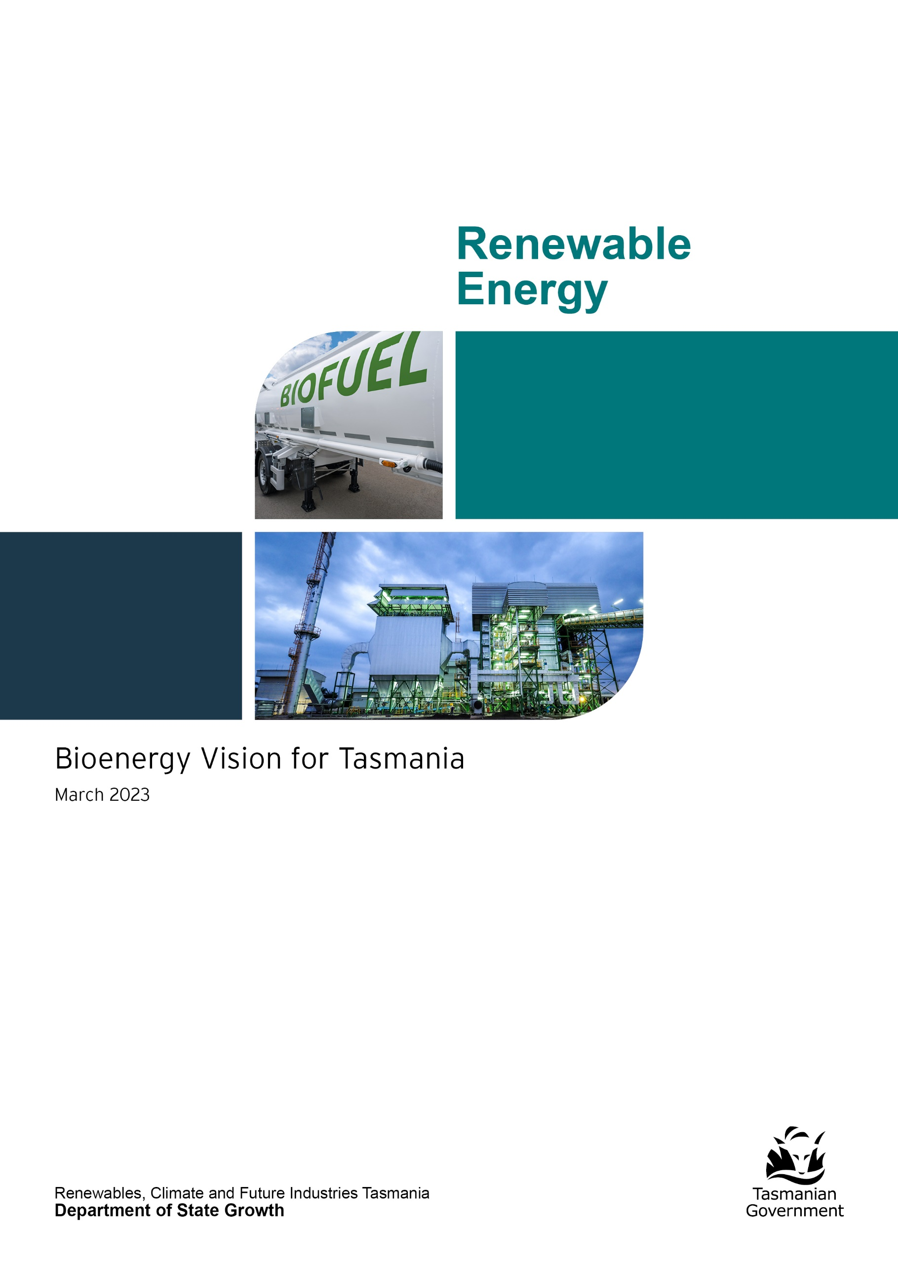

Contents
Ministerial foreword 1
Introduction 2
Background 4
What is bioenergy? 4
Tasmania’s current bioenergy status 5
Potential for bioenergy in Tasmania 6
Tasmania’s bioenergy production potential 6
Tasmania’s bioenergy challenges 8
Benefits of developing Tasmania’s bioenergy sector 9
Renewable energy production 11
Reduction of greenhouse gas emissions 12
Waste management and resource recovery 13
Jobs and economic development 13
Government policy relevant to bioenergy 16
The Tasmanian Government’s role 17
Government procurement 17
Building industry and community awareness of bioenergy 17
Exploring opportunities to deploy bioenergy in Tasmania 17
Developing a more sophisticated, mature and diverse bioenergy industry in Tasmania 18
Ensuring an enabling environment 18
Appendix 20
Glossary 20
References 21
Photo credits 21

Ministerial foreword
We sit on a huge untapped energy potential in Tasmania.
As a state that has long embraced renewable energy, one that is not beholden to fossil fuel energy sources such as coal or gas and one that is founded on making the best use of the resources we have, recognising the value of reclaiming what would otherwise become waste makes sense.
Bioenergy is being adopted ever more widely around the world but uptake continues to lag in Australia, and that includes right here in Tasmania.
With our reputation as Australia’s clean, pure and natural state there is an imperative to use what would otherwise, and traditionally has been, discarded.
Bioenergy is part of our broader vision for Tasmania to be a world-leader in renewable energy, building a truly sustainable, prosperous economy based on affordable, reliable, clean energy.
Worldwide, bioenergy accounts for more renewable energy generation than all other sources combined and we are laying the foundations for making the most of this abundant resource through this Bioenergy Vision for Tasmania.
Our bioenergy potential complements and bolsters our push towards becoming a renewable energy powerhouse that makes our clean energy generation capacity work for all Tasmanians, lowers household and business energy costs, grows our economy and supports local jobs.
With more than 1.3 million tonnes of solid organic waste and residues and 7.8 million tonnes of liquid organic waste and residues produced in Tasmania each year from agriculture, industry, municipal and forestry sources, there is an existing payload of bioenergy fuel to draw upon to replace traditional fossil fuels in almost every energy market.
By taking this industrial by-product and using it for energy generation we can reduce the levels of this abundant yet disregarded material going to landfill or waste disposal processing and direct it to generating energy for uses such as residential and commercial heating, electricity and transport.
The Tasmanian Government sees this opportunity and has committed $10.1 million over four years to replace fossil fuels used in government-owned boilers with renewables focusing on bioenergy. Displacing fossil fuels, such as natural gas, used to heat government buildings including schools, hospitals and correctional facilities, will improve environmental, social and economic outcomes at sites around the state.
Bioenergy can advance our objectives in relation to climate change, renewable energy production, waste management and regional employment and economic development.

Hon Guy Barnett MP
Minister for Energy and Renewables

Introduction
Bioenergy is the largest source of renewable energy in the world and in Australia. Globally, bioenergy produces more energy than all other sources of renewable energy combined (International Energy Agency (IEA) 2018). In Australia bioenergy produces 47 per cent of the nation’s total renewable energy consumption and 3 per cent of total energy consumption, with the potential to grow this to 20 per cent (Enea and Deloitte for ARENA 2021).
The Tasmanian Government recognises the important role bioenergy can play in Tasmania’s energy systems and is committed to exploring opportunities in the state to support an increased investment in bioenergy.
The Tasmanian Renewable Energy Action Plan (TREAP) sets out the government’s commitment to develop a bioenergy vision, in consultation with industry and stakeholders, to identify how to unlock private sector investment in bioenergy in Tasmania, increasing employment, reducing waste and greenhouse gas emissions while producing more Tasmanian renewable energy.
Tasmania’s bioenergy vision:
To embed bioenergy as a valued renewable resource for the Tasmanian economy, community, and environment as an aid to energy production, waste management and resource recovery and reduction of greenhouse gas emissions.
This bioenergy vision sets out the opportunity for bioenergy from a Tasmanian context, with a focus on creating an environment that unlocks investment to deliver against the key drivers of bioenergy adoption:
- renewable energy production
- greenhouse gas emissions reduction
- waste management and resource recovery (supporting the circular economy)
- jobs and economic development.
The development of this bioenergy vision has been informed through:
- Consultation with an extensive range of stakeholders representing agriculture, aquaculture, waste management and resource recovery, forestry and timber processing, power generation, industrial energy users, transport, peak industry bodies, construction and government.
- Consideration of the maturity of the global bioenergy sector.
- Research by experts such as Bioenergy Australia and the Australian Government’s National Bioenergy Roadmap (Roadmap).
- Public feedback on the draft Bioenergy Vision for Tasmania. Respondents included environmental groups, investors, industry representatives, regulators, infrastructure providers and individual respondents. Public feedback can be found at www.recfit.tas.gov.au
The Tasmanian Government is committed to the development of a bioenergy sector that encompasses social, environmental, and economic values to achieve the best outcomes for Tasmanians. This includes a government policy and regulatory framework to provide a foundation for long-term investment in the sector and stimulate private investment in commercially and environmentally sustainable bioenergy projects.

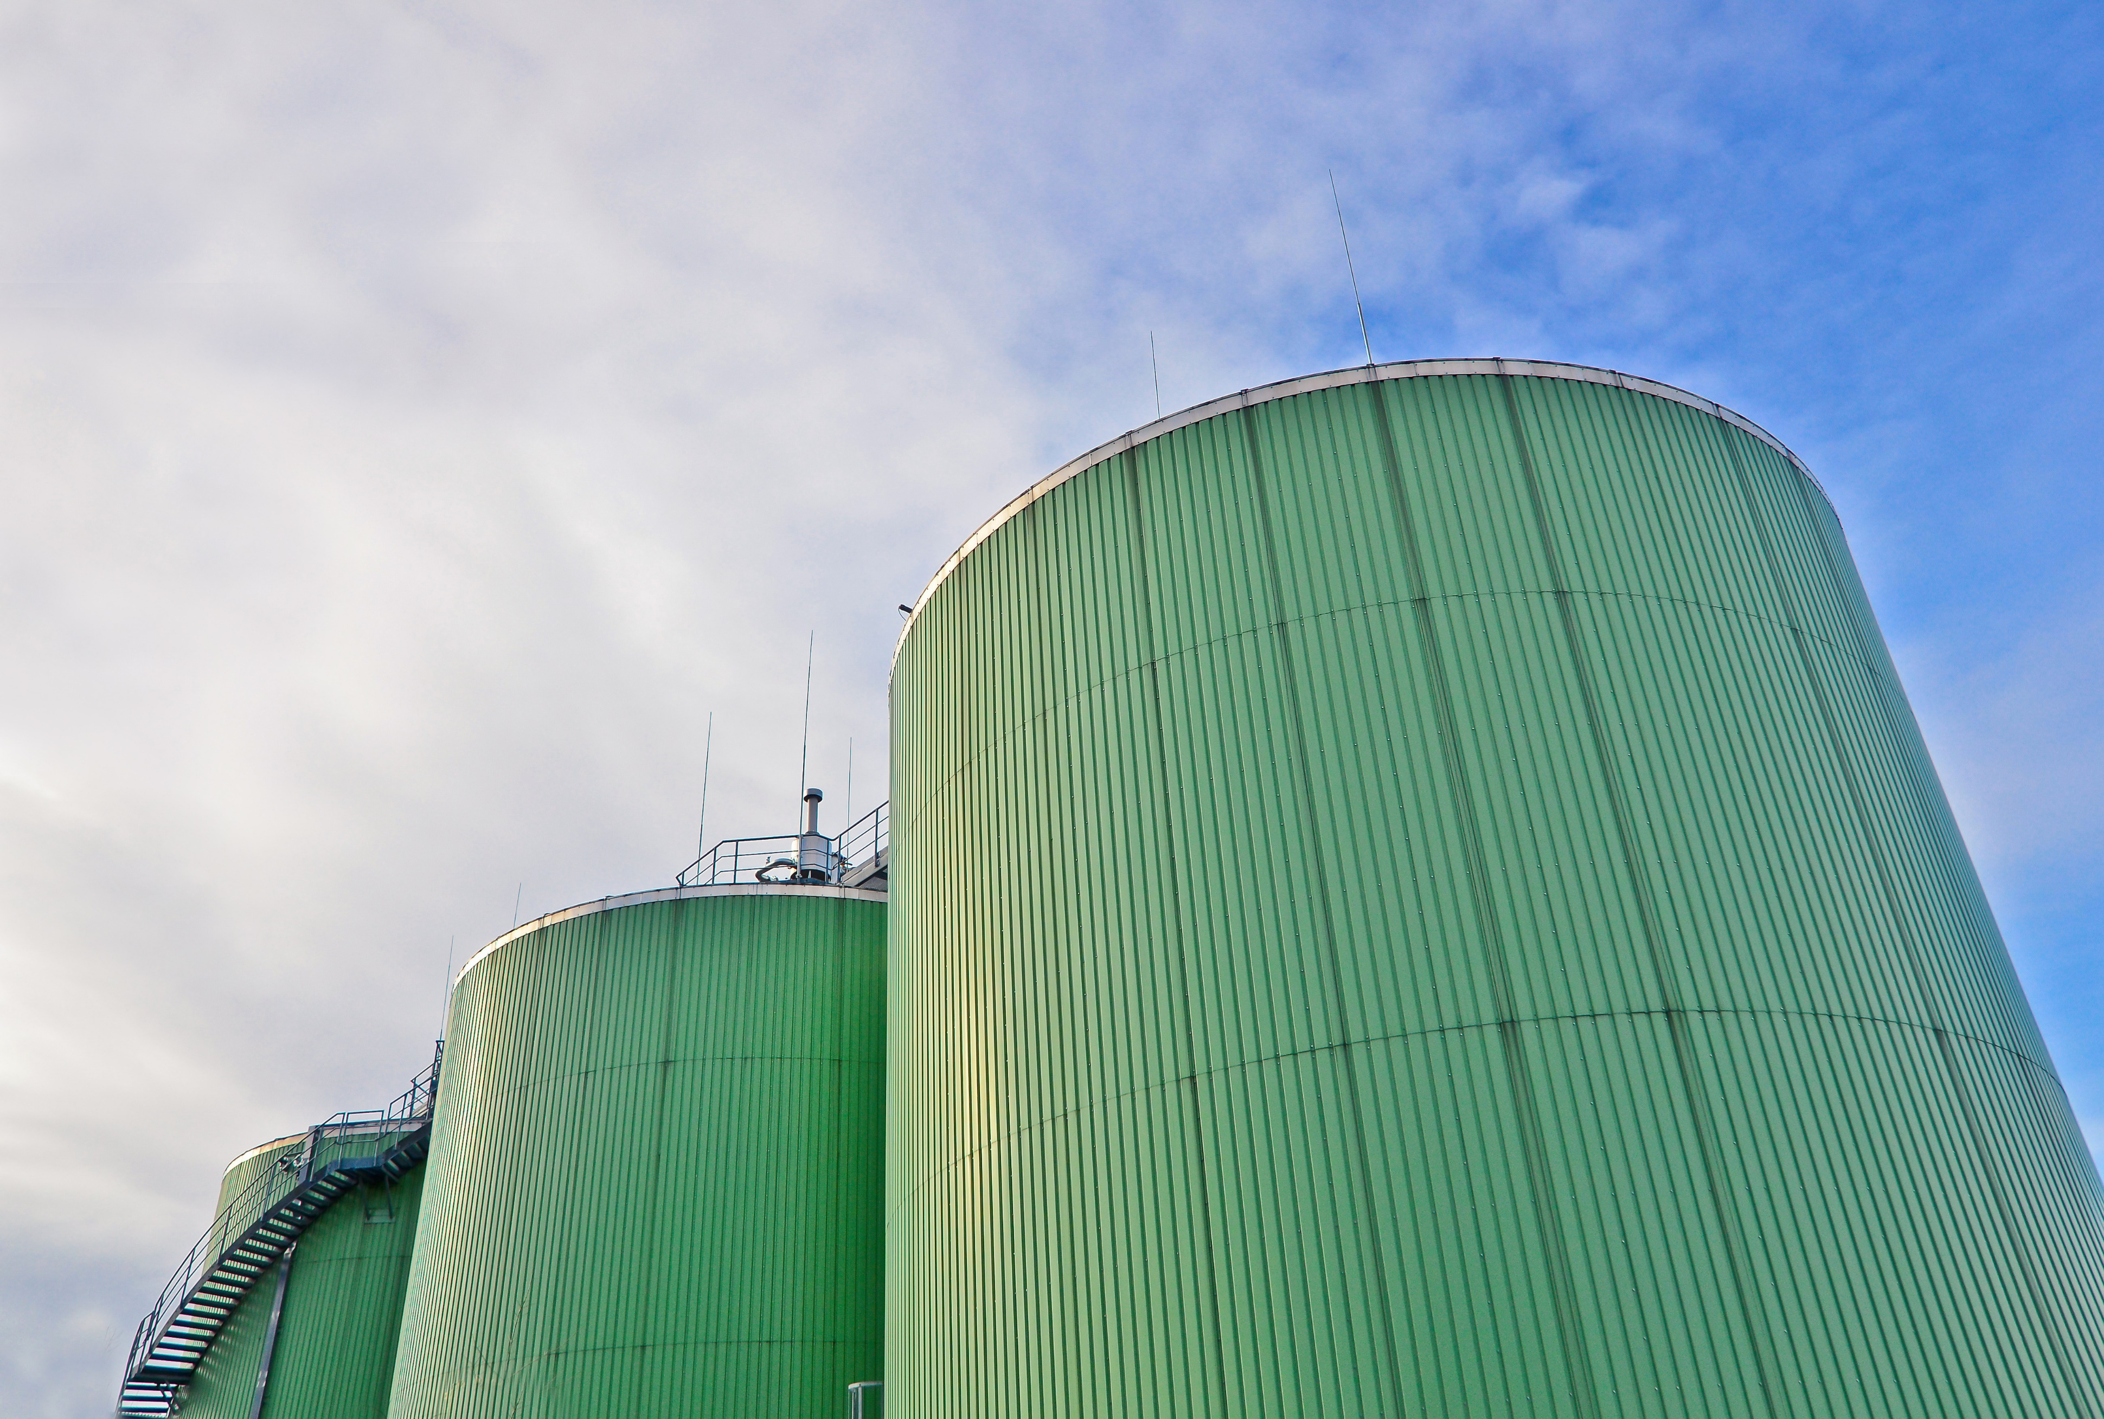
Austral Bricks (Longford)
This facility produced the world’s first certified carbon-neutral bricks. Sawdust displaced diesel to fire their brick making kilns in the 1980s, though the kiln still required some oil and diesel fuel. In 2012 the plant was connected to LPG and Austral Bricks had the choice to convert to LPG or fully convert to sawdust. Austral Bricks decided to fully convert to sawdust and undertake an energy efficiency project in the plant and seek carbon-neutral certification. In 2013, Austral Bricks estimated it had reduced carbon emissions by 8,392 tonnes of CO₂ equivalents per year. The conversion to bioenergy lowered fuel costs as sawdust is cheaper than fossil fuels, even though there were some additional costs to handle the sawdust. After the conversion, architects generated demand for the carbon-neutral bricks for sustainable developments including for the construction of net-zero greenhouse gas emission buildings. Production of carbon neutral bricks in Longford helps Austral Bricks achieve sustainability goals and shareholder commitments. Furthermore, using sawdust in place of fossil fuels employs an additional three full-time equivalent roles handling the sawdust and monitoring its performance in the kiln. Secondary employment is also generated collecting and transporting the 10-12 truckloads of sawdust delivered to the site each week.

Background

What is bioenergy?
Bioenergy is energy produced from organic matter. It can be produced from almost any agricultural, industrial, municipal and forestry organic matter. Organic waste and residues sourced from agriculture, municipal and forestry activities such as crop wastes and remains, manures and sludges, rendered animal fats, used oils, food and garden organic waste, timber harvesting and processing residues, construction and demolition woody waste and residual municipal solid waste are known collectively as ‘biomass’ and can be used as feedstock for bioenergy production.
Bioenergy can produce a wide variety of energy outputs including electricity, heat, fuels such as methane, and transport fuels for cars, boats, and planes. As biomass can be regrown sustainably, bioenergy is globally recognised as a renewable energy. It can displace fossil fuels in almost every market and reduce greenhouse gas emissions. A bioenergy facility can produce a variety of energy sources including:
- liquid fuel from used cooking oil and forest harvest and processing residues
- gas for heating and power from poultry farms, animal manures, brewery sludges, and dairy and meat processing waste
- heat and cooling from municipal waste and agriculture and timber industry residues
- power from all of the above waste materials, including base-load power.
Bioenergy facilities are able to provide energy at a range of scales, from individual homes to industrial processes and providing energy to the market.

Cascade Brewery (Hobart)
In 2014, Cascade Brewery displaced natural gas with biogas generated through the installation of an anaerobic digester. Annually around 70,000 m³ biogas is produced and burned in a modified natural gas boiler to provide steam used throughout the brewing process. This reduces greenhouse gas emissions by approximately 50 tonnes of CO₂ equivalents annually and reduces energy costs by approximately $20,000 each year. Furthermore, extensive trade waste charges are avoided by treating the organic wastes onsite.
The anaerobic digestor has generated an additional full-time role managing the anaerobic digestor as well as secondary employment with truck drivers and service providers. The plant is monitored 24/7 to ensure it complies with very strict parameters for its operation. Brewery waste streams are released from holding tanks at the most optimal time to maximise the usage of biogas. This world-class facility is an integral part of Cascade’s drive for environmental sustainability.

Tasmania’s current bioenergy status
The most common application of bioenergy in Tasmania is the use of wood to heat homes with approximately one quarter of Tasmanian households primarily relying on this type of heating (Australian Bureau of Statistics 2014).
There are industrial scale examples of bioenergy in Tasmania including 10 industrial-scale boilers or kilns that combust sawmill residues or woodchips. These boilers and kilns are used to dry sawn wood, fire bricks, cook vegetables, heat greenhouses for vegetable, flower, and nursery production, provide heat to a meat processor and heat water and spaces in a sports complex. In most cases the boiler or kiln was installed because it was the cheapest source of heat energy available but for sawmills they also provide a convenient way of disposing of timber processing wastes. Other businesses intentionally use wood waste and residues to replace their use of fossil fuels and therefore reduce their greenhouse gas emissions.
There are 13 industrial scale anaerobic digesters in Tasmania that are used to treat sewage as well as organic-rich liquid wastes from meat processors, a brewery, a dairy processor and a chocolate manufacturer. The anaerobic digestion process converts organic matter into biogas (methane and other gases) which can produce heat for industrial processes, accelerate sewage decomposition or simply be flared into the atmosphere. The predominant driver for the adoption of anaerobic digestion technologies was reducing waste management costs. Other drivers included reducing energy costs and lowering greenhouse gas emissions.
LMS operates five landfills in Tasmania where biogas produced from the natural breakdown of organic material is collected and used as a fuel to generate renewable electricity. Electricity is produced from combusting methane in biogas which converts it into carbon dioxide reducing the warming potential of released gases by more than 95 per cent. The renewable electricity is sold to the electricity grid.
Methane produced from wet organic waste could be used on-site to generate energy or distributed through the Tasmanian Gas Network reducing Tasmania’s reliance on natural gas imports while contributing to gas decarbonisation in Tasmania.
More detailed examples of bioenergy facilities operating in Tasmania and interstate can be found in the Appendix.
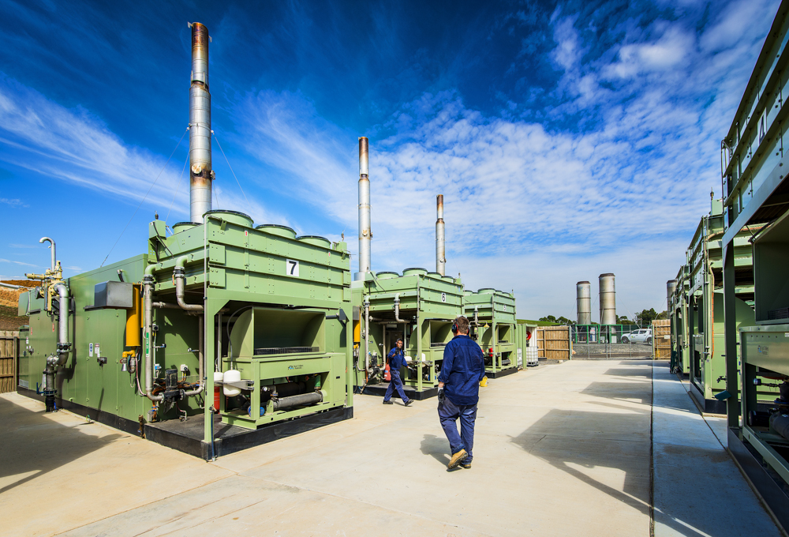

Potential for bioenergy in Tasmania

Tasmania’s bioenergy production potential
Tasmania produces large quantities of various organic waste and residues that could produce a wide range of energy types. The Australian Biomass for Bioenergy Assessment (ABBA) Project funded by the Australian and Tasmanian governments recently found that Tasmania annually produces
7.8 million tonnes of liquid organic waste and 1.4 million tonnes of solid organic waste from municipal, agricultural, forestry and industrial sources.
Figure 1. Quantities of organic waste that may be made available for bioenergy production annually in Tasmania (2016)
¹ Rothe, A., Forest biomass for energy: Current and potential use in Tasmania and a comparison with European experience. Zentrum Wald Forst Holz Weihenstephan, University of Applied Sciences, Weihenstephan-Triesdorf, 2013
² Australian Biomass for Bioenergy Assessment Project.
There is an opportunity for some of Tasmania’s energy market to be supplied by bioenergy.
This includes new energy generation and for bioenergy to displace fossil fuel use and reduce greenhouse gas emissions.
Bioenergy in the form of biofuels could potentially displace some of the 1 billion litres of transport fuel sold in Tasmania each year (Figure 2). Biogas could also displace a proportion of the 7-10 thousand terajoules (TJ) of energy consumed as natural gas from the Tasmanian Gas Pipeline (TGP) to Tasmania or sold to interstate customers through the TGP.
While Tasmania is now 100 per cent net self-sufficient in renewable electricity, additional renewable electricity could be used behind the meter to reduce electricity costs or be sold into the National Electricity Market.
Figure 2. Existing Tasmanian energy markets
³ Australian Petroleum Statistics, December 2021, Department of Industry, Science, Energy and Resources
⁴ Energy in Tasmania Report 2020-21. Tasmanian Economic Regulator March 2022

Tasmania’s bioenergy challenges
Tasmania and Australia lag many other nations in the uptake of bioenergy (O’Hara et al. 2018), despite having large quantities of waste and residue organic streams and strong demand for energy that bioenergy could produce.
There is currently a lack of knowledge and familiarity with bioenergy in Tasmania. This may attribute to why bioenergy is often not considered, or is considered too risky, for applications such as:
- a renewable energy source
- a waste solution
- an approach to reduce greenhouse gas emissions
- to stimulate regional employment and economic development.
Furthermore, while bioenergy has social and environmental benefits, there are also social and environmental challenges to be considered.
Few bioenergy technology providers have permanent representatives in Tasmania and the few industrial-scale bioenergy facilities installed in Tasmanian businesses are not well known or publicised. In addition, not all forms of bioenergy currently exist in Tasmania. For example, no Tasmanian enterprises use biomass to produce combined heat and power, transport fuels or biogas for injection into the gas grid. Greenhouse gas abatement was not a key driver for establishing most bioenergy facilities and none were explicitly established to stimulate regional employment or economic development.
Bioenergy facilities are long-term investments that require long-term energy offtake and feedstock supply agreements and confidence that facilities can operate for long time horizons to achieve a return on investment. In addition, they are often more complicated and expensive to install and maintain and require a larger footprint and specialised knowledge of the technology and its benefits to enable successful deployment.
Biomass feedstocks used in bioenergy production are often bulkier more dispersed and variable in quality than alternative fuels necessitating more complex supply chains to gather, transport, store and deliver the feedstock to bioenergy facilities. Consequently bioenergy feedstock supply agreements and supply chains can be complex and difficult to establish. While feedstock supply chains exist in Tasmania, the lack of specifications for the feedstock quality and variability in the quality of the fuel currently delivered has potentially deterred investment in bioenergy facilities.
In some instances, older bioenergy facilities have been associated with smoke production, particulate emissions and smells that have given the technology a poor reputation.
These challenges are not insurmountable, but practical solutions may not be widely known due to the Australian market’s limited uptake and knowledge of bioenergy technologies. The higher establishment costs of bioenergy facilities are often offset by lower fuel and reduced waste management costs that can make bioenergy the cheapest energy source when a life-cycle analysis is conducted. Many feedstock supply chain challenges can be overcome by generating bioenergy at the source of organic waste production or on smaller scales, if appropriate. Moreover, modern bioenergy facilities operate cleanly and comply with strict environmental standards.
It is also important to recognise that not all biomass is appropriate for bioenergy production. Some biomass can and should be reused, recycled, used to produce higher-value products or left in the landscape to preserve environmental values. Producing bioenergy from higher value products such as food crops and high value wood or native vegetation harvested solely for bioenergy production is unlikely to be economically, socially or environmentally sound. The focus of the Bioenergy Vision for Tasmania is on the utilisation of organic waste and residue streams.

Benefits of developing Tasmania’s bioenergy sector
Developing the bioenergy sector will need to encompass social, environmental, and economic values to achieve the best outcomes for Tasmanians. The Tasmanian Government is committed to a policy and regulatory framework supporting long-term investment in commercially and environmentally sustainable bioenergy projects.
This bioenergy vision recognises four key drivers for the adoption of bioenergy. Bioenergy is differentiated from most other energy sources in that it can deliver solutions for these drivers simultaneously.

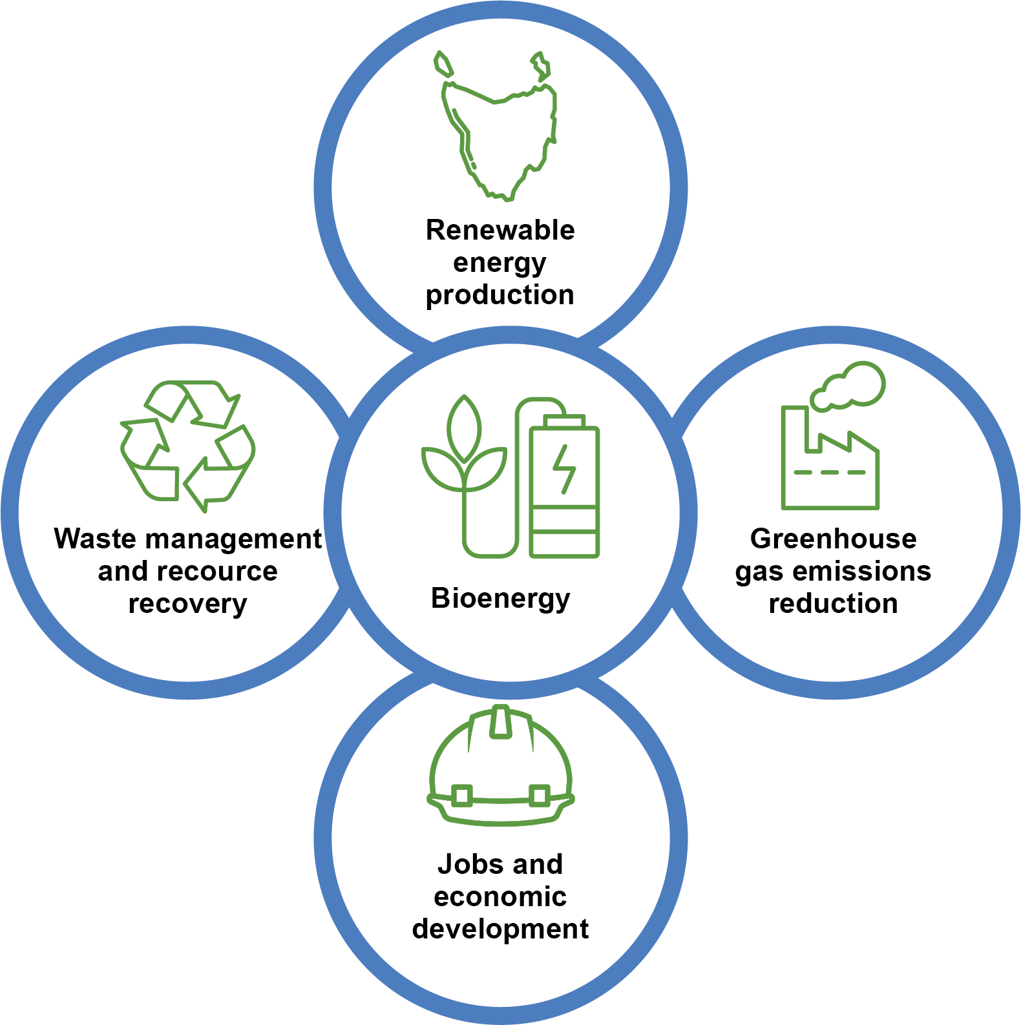
LMS Energy (multiple Tasmanian sites)
LMS Energy works with councils and waste authorities who operate landfills to capture and use biogas that is generated by the natural breakdown of organic wastes. LMS designs, installs and operates biogas capture systems for the landfills. These prevent the landfill biogas, which contains methane, a powerful greenhouse gas, from being emitted into the atmosphere. LMS uses this biogas as a fuel to generate renewable electricity which converts methane into carbon dioxide. Methane‘s atmospheric warming potential is equivalent to more than 28 times that of carbon dioxide. Hence converting methane to carbon dioxide reduces greenhouse gas emission CO₂ equivalents by more than 95 per cent.
LMS captured nearly 21 million cubic metres of landfill biogas in 2021-22. This reduced Tasmania’s greenhouse gas emission by approximately 200,000 tonnes of CO₂ equivalent emissions per year, equivalent to taking 81,000 cars off the road, and provided 27GWh of renewable electricity, enough to power 3,600 average households.
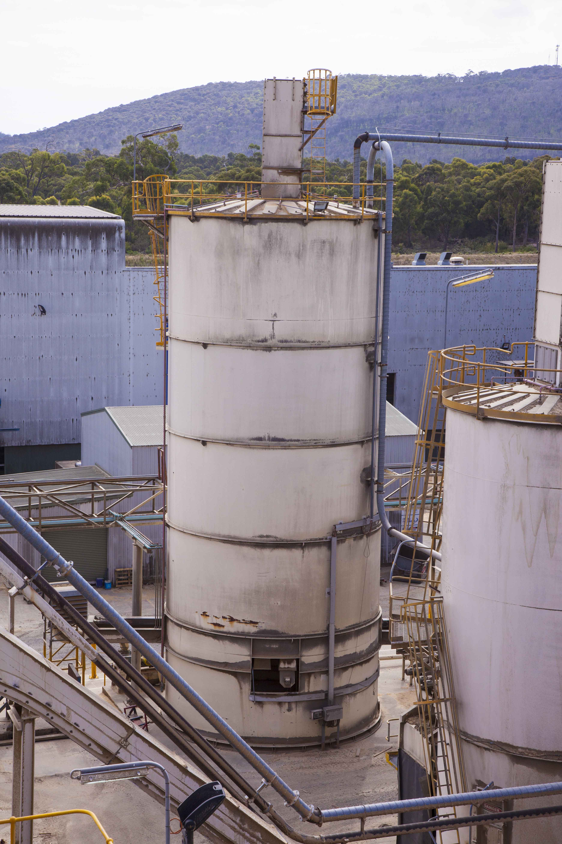
LMS’ biogas operations directly employ four full-time positions in Tasmania and support extra indirect jobs through regularly visiting staff (e.g. with accommodation, transport and food services). With LMS estimating its total Tasmanian biogas gas reserves at 12 petajoule (PJ) for 2022-2040, landfill biogas also has the potential to be upgraded into biomethane, green hydrogen or biofuels to replace natural gas or transport fuels and further reduce Tasmania’s greenhouse gas emissions.

Renewable energy production
The Tasmanian Government has identified renewable energy as a key economic driver. The TREAP sets out the pathway to deliver on the government’s vision of utilising renewable energy to benefit all Tasmanians through job creation, helping our environment and driving investment and economic growth. The TREAP recognises bioenergy as one of the renewable energy sources that can contribute to this.
Bioenergy can generate many forms of energy from various organic feedstocks by using a range of technologies.
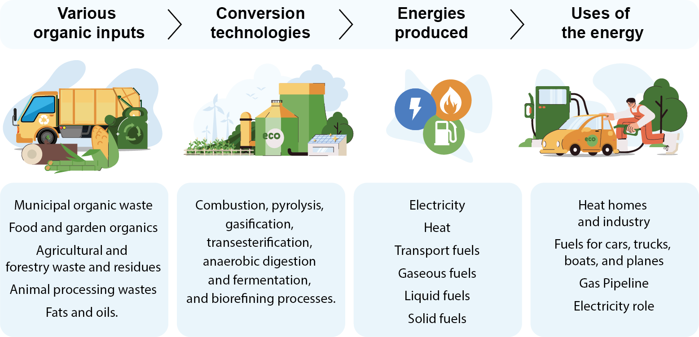
Figure 4. Bioenergy products, converstion technologies and feedstocks
Globally, approximately half the total renewable energy consumed in 2017 was generated by modern bioenergy technologies according to IEA (2018). The IEA identified bioenergy as the overlooked giant of renewables with its growth expected to be higher than other renewables for the near future.
In 2019-20, bioenergy produced 47 per cent of Australia’s renewable energy consumption (Department of Industry, Science, Energy and Resources 2021). The major sources of bioenergy generation were from woody biomass and bagasse with minor bioenergy generation from municipal and industrial waste, and from the consumption of biogas and transport fuels made from biomass.
Since biofuels are often produced locally, bioenergy use could improve Tasmania’s fuel security by reducing Tasmania’s reliance on imported fuels, including more than 1 billion litres of fossil fuels each year (Figure 2).

Reduction of greenhouse gas emissions
The carbon released from using biomass fuels is reabsorbed as biomass regrows making bioenergy a source of renewable energy with low greenhouse gas emissions (Figure 5). Greenhouse gas emissions can be reduced when bioenergy displaces fossil fuels. Bioenergy is one of the few renewable energy sources that can displace fossil fuels in almost every energy market.
The Intergovernmental Panel on Climate Change (IPCC) and the IEA identify a key role for bioenergy to achieve the Paris Agreement, which aims to keep the global temperature rise well below 2˚C (IPCC; IEA 2017) and in pathways that limit global warming to 1.5˚C (IPCC 2018).
The Australian Government has acknowledged the emissions reduction potential of bioenergy through the work of the Australian Renewable Energy Agency (ARENA), the Clean Energy Finance Corporation (CEFC) and the Australian Clean Energy Regulator (ACER) where there are several methodologies that enable Australian Carbon Credit Units to be earned from some applications of bioenergy (ACER 2021).
The Tasmanian Government has legislated a target of net-zero emissions, or lower, from 2030. The target was recommended as part of the Independent Review of the Climate Change (State Action) Act 2008 and supported by Tasmania’s Emissions Pathway Review and a detailed economic analysis of the impact on jobs, industry and growth.
Tasmania’s Emissions Pathway Review identified bioenergy’s potential to reduce emissions from industrial manufacturing and processing by replacing fossil fuels used for high temperature process heat.
The emissions reductions and renewable energy generation potential of bioenergy support policies and initiatives that transition Tasmania to a low emissions economy.
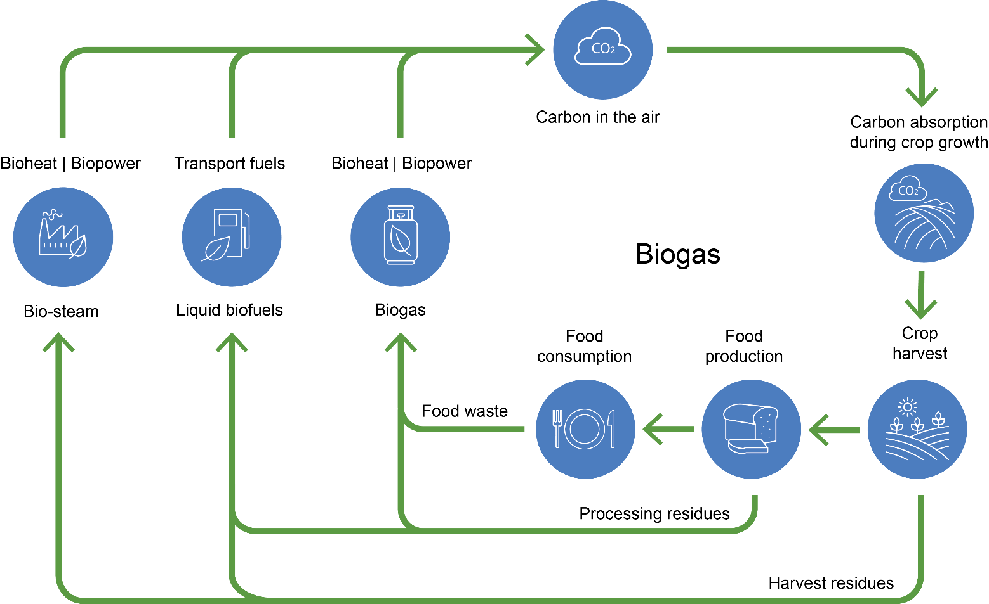
Figure 5. Biomass for bioenergy carbon cycle

Waste management and resource recovery
Biomass is consumed to produce energy at bioenergy facilities. Bioenergy facilities can consume organic waste and residue streams that arise from agricultural activities including crop harvesting and processing residues, municipal sources such as food and garden organics, residual municipal solid waste, woody waste from construction and demolition sources and forest harvesting and processing waste and residue streams.
Without appropriate management, waste and residue streams can accumulate in businesses and the environment, creating potential hazards to public health and safety including pollution and increased fire risks. Waste management, processing and disposal often comes at a significant cost to businesses and society.
Efforts to address waste include producing less waste, greater resource recovery and re-use and reducing the amount of organic waste going to landfill. These practices are consistent with the 2018 National Waste Policy and the Tasmanian Waste Action Plan and, more broadly, with circular economy principles.
In addition, the use of biomass, whether from native forestry or plantations, in field forest operations or industrial residue, bioenergy generation is a legitimate opportunity to add value to the forestry sector. The Tasmanian Government has supported a number of studies focused on maximising the value and utilisation of forest residues www.stategrowth.tas.gov.au/energy_and_resources/forestry/residues
A circular economy is structured to maximise the use and value obtained from materials and resources at every stage of the life of a product or material. The principles of the waste hierarchy that focus on waste prevention are an essential component of how we manage waste and resource recovery in a circular economy. Waste prevention principles ensure we design our waste and prioritise resource recovery, repurposing and recycling.
Moving towards a circular economy while applying the waste hierarchy is expected to reduce waste, promote innovation and achieve a more creative, robust and productive economy. Bioenergy should foster and not prevent waste reduction, recovery, repurposing and recycling to enable the ‘highest value’ sought for organic material. However, when organic material reaches end of life one of its valuable uses can be to provide energy to society. Furthermore, bioenergy facilities can produce bio products that contribute to the circular economy such as biochar from combustion processes, digestate as soil amendment from anaerobic digestion and a variety of high value chemicals from producing transport fuels.
Waste and residue streams that do not have alternative higher-value markets in the circular and bio-economies or that reach end of life can be used to generate bioenergy. Further, bioenergy facilities can also play a role in aggregating organic material, facilitating reuse and recycling with those higher-value uses in mind and with the high-value products made using bioenergy. There are currently many opportunities to use waste organic material for bioenergy as bioenergy provides a better outcome than current management practices for many waste streams and the quantities of organic waste generated will allow the bio-economy and bioenergy to coexist.

Jobs and economic development
Bioenergy can contribute to regional economic development through the local production of fuels that can substitute for imported fuels and ensure that a larger proportion of fuel expenditure is retained in the local community. Bioenergy requires more complex feedstock collection and handling supply-chains and equipment than most alternative forms of energy generation, providing significant opportunities for employment, especially in rural and regional areas where most of the feedstock tends to be located.
Employment benefits associated with bioenergy have been observed by the International Renewable Energy Agency which reviews renewable energy and associated jobs on annually. Their 2021 review reports the global employment in the bioenergy sector was 3.52 million jobs in 2020, up from
2.4 million jobs in 2012 (IRENA and ILO 2021).
Producing transport fuels provides further examples of the potential for bioenergy to provide jobs and grow the economy. The Queensland University of Technology report ‘Biofuels to bioproducts: a growth industry for Australia’ describes how increased use of 10 per cent ethanol‐blended petrol (E10) in Australia could create 2,080 direct jobs and up to 6,570 indirect jobs, potentially attracting A$1.56 billion of investment and generating more than A$1.1 billion of additional revenue per year in regional communities. According to the ARENA and CEFC report ‘Biofuels and Transport: An Australian opportunity’, an Australian biofuels production target of 20 gigalitres per year could provide long-term employment for up to 250,000 people, mostly in regional areas.
Businesses supplying organic waste and residues, including industries processing organic feedstocks and agricultural and forestry enterprises, can become more competitive by reducing waste costs and through more efficient utilisation of harvested products. Bioenergy provides opportunities to reduce waste management costs or even turn a waste stream into a viable commodity supporting the government’s objectives to grow the agricultural and forestry sectors.
At the individual enterprise level, bioenergy provides opportunities for agricultural, forestry and downstream processing businesses that produce organic waste and residues to enhance their competitiveness. Producing bioenergy can turn waste streams into a valuable commodity. Reducing
on-farm waste by capturing value from a larger proportion of harvested materials aligns with the Circular Economy and Value Adding emerging priority under the Tasmanian Government’s Competitiveness of Tasmanian Agriculture for 2050 White Paper and the government’s goal of sustainably growing the farm gate value of Tasmania's agricultural sector to $10 billion per year by 2050.
The Tasmanian Government’s 2017 Tasmanian Wood Encouragement Policy acknowledges and supports renewable energy production from wood. By helping to secure a profitable use for harvest and processing residues, bioenergy can also support the Tasmanian Government’s Strategic Growth Plan for the Tasmanian Forests, Fine Timbers and Wood Fibre Industry (2017) by improving the long-term competitiveness of the sector.
Timberlink (Bell Bay)
Timberlink’s Bell Bay mill, commissioned in 2008, is the only large scale, forest-integrated plantation softwood sawmilling company located in Tasmania. The mill produces a wide range of products with a mix of structural framing, outdoor structural framing, fencing, landscaping, decorative and industrial products. Sawdust from the timber milling process that would otherwise need to be disposed of or sold is burned in a 20MW capacity boiler to produce heat energy for the facility to dry sawn wood.
Biomass produces energy at 1/20 the equivalent costs of the renewable alternative, electricity, or 1/15 the cost of LNG, the likely alternative fossil fuel energy source. Alternative markets for the sawdust do not price compete for energy. Using wood waste for energy production instead of LNG prevents roughly 17,000 tonnes of CO₂ equivalents per year from being emitted. Furthermore, using sawdust employs an additional three full time equivalent role managing the sawdust feedstock and heat plant.
Timberlink directly employs 200 people at Bell Bay as well as using local contractors and businesses wherever possible. In 2020 Timberlink estimated the indirect economic impact of the Bell Bay mill on the local economy to be $150 million.
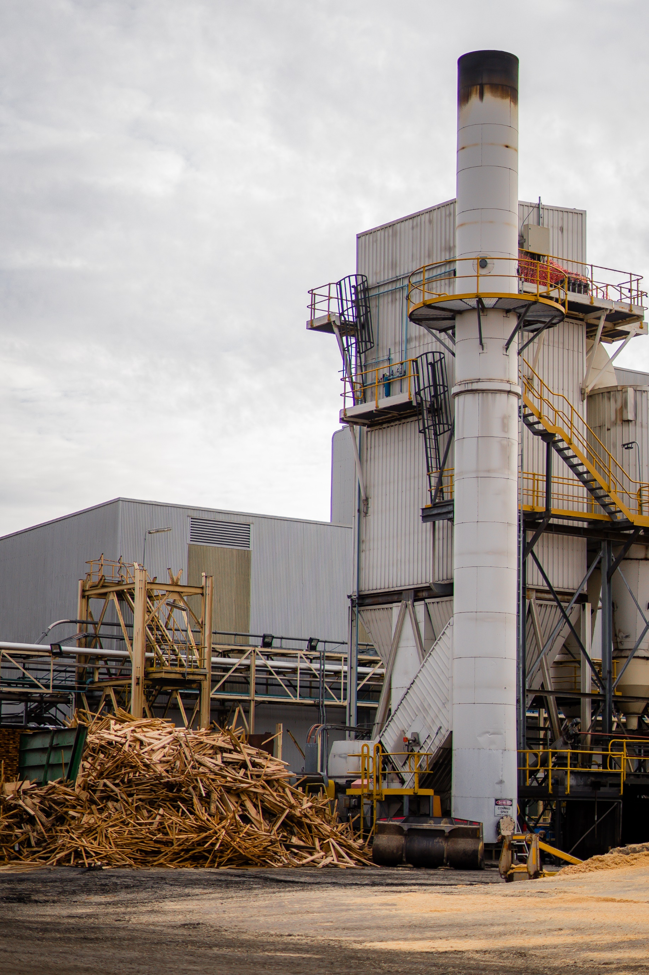
Neville Smith Forest Products (Mowbray)
In 2017, Neville Smith Forest Products (NSFP) installed a pellet mill at its Mowbray, Tasmania site.
The pellet mill creates wood pellets from sawdust, a waste stream from timber mills that was previously disposed of in landfill at a cost of approximately $140 per tonne. Wood pellets are sold as fuel for pellet fired heaters for homes and businesses, patio heaters, BBQs and boilers for industrial applications. These can replace fossil fuel burning alternatives and reduce greenhouse gas emissions.
The NSFP Mowbray mill annually produces 3,000 tonnes of pellets, injecting approximately $2 million into the local economy, creating 2-3 full time jobs directly, with additional indirect employment generated in the form of forklift drivers, truck drivers and store hands. Pellets burn clean due to low moisture contents of approximately 10 per cent and have high thermal efficiency. Pellet heaters sold in Tasmania typically have 70 per cent thermal efficiency. Tasmania currently supplies approximately 60 per cent of Australia’s pellet consumption with room for expansion in sales in Tasmania, interstate and internationally.

Government policy relevant to bioenergy
The Tasmanian Renewable Energy Action Plan (TREAP) identified the need for the Tasmanian Government to develop a Bioenergy Vision for Tasmania in response to expert advice indicating the potential to generate more renewable energy from Tasmania’s organic waste and residues. Producing bioenergy and biofuels from organic waste and residue streams can provide low-cost renewable energy, help to decarbonise the economy by replacing fossil fuel use and support regional employment.
The Tasmanian Government’s Tasmanian Wood Encouragement Policy 2017 acknowledges and supports renewable energy production from wood. By helping to secure a profitable use for harvest and processing residues and improving the long-term competitiveness of the sector, bioenergy can also support the government’s Strategic Growth Plan for the Tasmanian Forests, Fine Timbers and Wood Fibre Industry (2017).
By replacing fossil fuels, bioenergy will help to achieve the Tasmanian Government’s legislated target of net-zero emissions, or lower, from 2030. The target was recommended as part of the Independent Review of the Climate Change (State Action) Act 2008 and supported by Tasmania’s Emissions Pathway Review and a detailed economic analysis of the impact on jobs, industry and growth. The review highlighted bioenergy’s potential to reduce emissions from industrial manufacturing and processing by replacing fossil fuels used for high-temperature process heat as well as opportunities to increase landfill biogas capture and use.
Bioenergy supports the Draft Waste Action Plan 2019 by reducing the quantity of waste going to disposal through organic waste aggregation. Bioenergy can support the circular economy and the diversion of waste to the bio-economy and higher and more valuable uses for waste that are preferred outcomes.
Bioenergy can complement Tasmania’s Sustainable Agri-Food Plan 2019-23 by turning agricultural and processing waste into an energy commodity, reducing waste disposal costs and increasing the profitability, competitiveness and sustainability of agricultural enterprises and processors. A competitive agri-food sector is necessary to achieve the Tasmanian Government’s goal of sustainably growing the farm gate value of Tasmania’s agricultural sector to $10 billion by 2050.
The Competitiveness of Tasmanian Agriculture for 2050 White Paper highlights the circular economy and value adding as one of three emerging priority areas for agriculture.
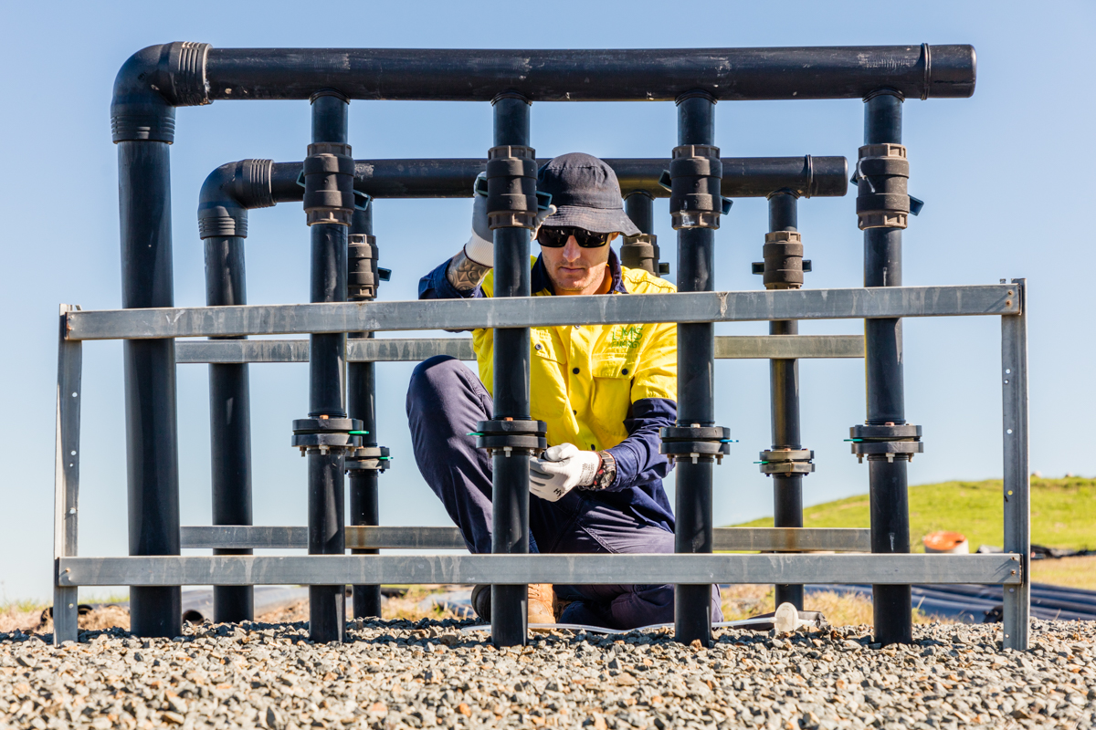

The Tasmanian Government’s role

Government procurement
Government procurement continues to support the bioenergy sector by promoting the adoption of bioenergy in relevant infrastructure projects. This builds familiarity with bioenergy technology adoption processes in Tasmania and is an important practical step to reduce the government’s greenhouse gas emissions.
The government allocated $100,000 through the 2020-21 State Budget to explore where renewable energy, and especially bioenergy, can displace fossil fuels used in government-owned boilers that heat government buildings. The 2022-23 State Budget committed $10 million over four years to implement renewable energy solutions for the 60 government-owned fossil fuelled boilers identified in the study. This will advance the government’s objectives in relation to climate change, renewable energy production, waste management and regional employment and
economic development.

Building industry and community awareness of bioenergy
The government has engaged with the community, businesses and experts in developing the Bioenergy Vision and continues to promote bioenergy through Renewables, Climate and Future Industries Tasmania (ReCFIT). ReCFIT is developing case studies and will host field trips to demonstrate current use of bioenergy in Tasmania and is working with businesses and local government to promote the consideration of bioenergy as a renewable energy option.

Exploring opportunities to deploy bioenergy in Tasmania
The Tasmanian Government, in collaboration with councils and the business community, will continue to facilitate and coordinate activities to explore bioenergy and encourage bioenergy adoption.
For most businesses, adopting bioenergy might already make economic and environmental sense by providing low-cost energy and waste management solutions, reducing greenhouse gas emissions, and even a point of difference with their customers.
Councils too in Tasmania are already adopting bioenergy solutions to help them better manage landfill gases, reduce greenhouse gas emissions and heat facilities.
The Tasmanian Government will provide information on the quantities or waste or residue organic matter that could be available for bioenergy generation. The Australian Biomass for Bioenergy Assessment (ABBA) dataset has been made available to the public online via the National Map (nationalmap.gov.au) and the Tasmanian Organics Research Report (2022).
The Tasmanian Government is developing an Emissions Reduction and Resilience Plan for the Energy sector as part of Tasmania’s actions to achieve its legislated net zero emissions target and supporting businesses and industry in the transition to a low emissions economy. The plan will be developed in consultation with key industry stakeholders, businesses and the community and will include specific actions to reduce emissions and build resilience across the stationary energy sub-sector, including the opportunity for bioenergy.
The Tasmanian Government will also work with the Australian Government to achieve the objectives in the Australian Bioenergy Roadmap.

Developing a more sophisticated, mature and diverse bioenergy industry in Tasmania
The Tasmanian Government will continue to promote bioenergy including bioenergy technologies and quantities of organic waste and residue potentially available for bioenergy generation.
The Tasmanian Government will develop a prospectus to promote Tasmania’s bioenergy potential bioenergy resource and options to prospective local, interstate and international investors.
The Office of the Coordinator-General is responsible for attracting and securing investment in major development projects in Tasmania that maximise their contribution to Tasmania's economic growth, which includes relevant bioenergy projects. The Coordinator-General will help streamline the Tasmanian business environment, promote competitiveness and provide advice on the assessment and approval of investment opportunities for relevant bioenergy projects.

Ensuring an enabling environment
Tasmania’s new legislated target of net-zero emissions, or lower, from 2030 will guide the further bioenergy development.
The Tasmanian Government has introduced a landfill levy, which came into effect on 1 July 2022 under the Waste and Resource Recovery Act 2022, as an economic instrument to encourage the diversion of organic waste from landfill to alternative end pathways such as bioenergy generation.
The government has also committed to reducing the amount of organic waste going to landfill by 25 per cent by 2025 and 50 per cent by 2030.
Councils play an important role in facilitating bioenergy projects by promoting different approaches, assisting with the aggregation of organic waste streams and connecting the energy production potential of bioenergy with the market.
The government will continue to advocate for the eligibility of electricity generated from native forest wood waste for Large-Scale Generation Certificates under the Renewable Energy Target.
Tasmania’s native forests are sustainably managed through effective policies and regulations, including the Comprehensive Adequate and Representative reserve system which delivers a better outcome than seeking to dictate end-use for wood products and forest residues.
ABEL Energy (Bell Bay)
ABEL Energy is developing Australia’s first integrated green hydrogen and methanol production facility at Bell Bay. Methanol is a versatile, environmentally friendly liquid alcohol used in numerous applications including as an industrial feedstock to make pharmaceuticals and hydrocarbons such as plastics and as an ultra-clean burning fuel for off-grid, heavy-duty transportation and power generation. Demand for green methanol is growing. For example, global shipping companies plan to replace fossil fuels with green methanol to power ships, reducing greenhouse gas emissions.
Every 200,000 tonnes of green methanol used as ship engine fuel will avoid up to 380,000 tonnes CO₂ emitted from fossil fuels. Globally, shipping is expected to require hundreds of millions of tonnes of new green methanol to be produced.
ABEL Energy plans to source carbon from certified Tasmanian plantation forests including forest residues and dead and fire-damaged trees that don’t meet minimum specifications for other uses. Hydrogen and oxygen will be sourced from water using a 140 MW electrolysis unit powered by Tasmania’s renewable electricity.
ABEL Energy’s Bell Bay initiative is underpinned by a successful $1.3 million feasibility study completed in May 2022 supported by a $555,000 Tasmanian Government grant and will proceed in two stages. Stage One will produce 200,000 tonnes of green methanol per year. The facility will operate year-round on a 24-hour cycle, and directly employ 50 people. Stage Two will increase annual methanol output to 300,000 tonnes. Some green hydrogen will also be supplied to adjacent industries.
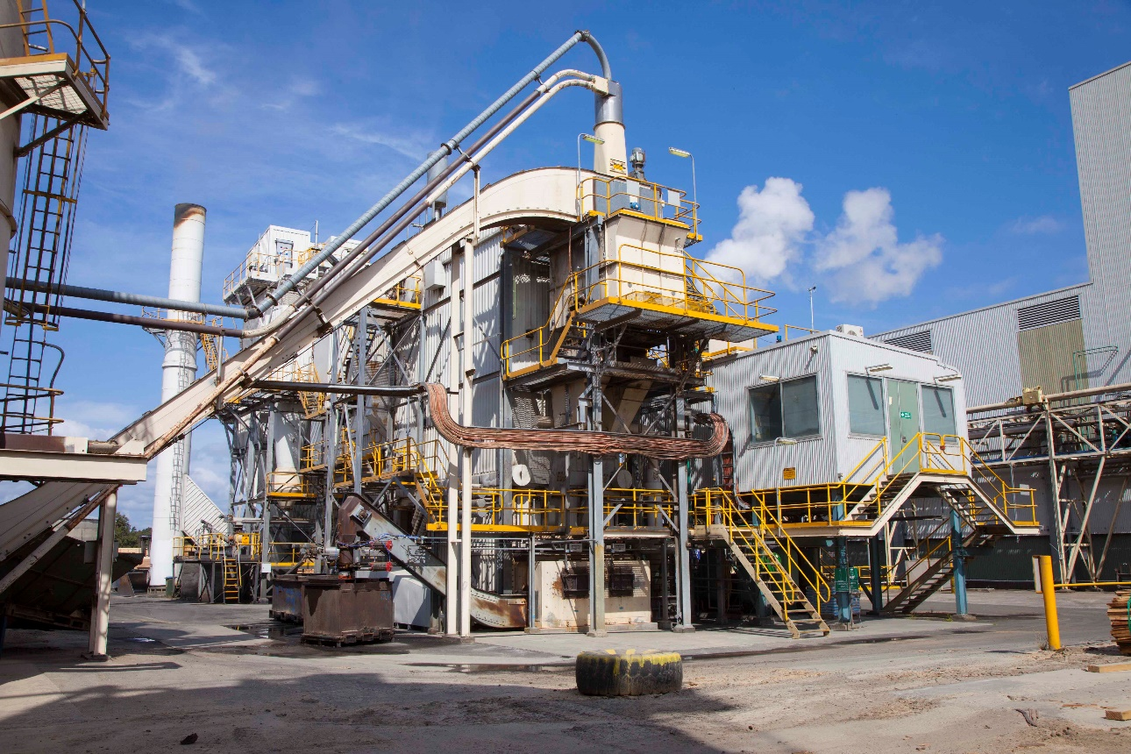

Appendix

Glossary
Anaerobic digestion | A process through which bacteria break down organic matter in the absence of oxygen, producing biomethane and other gasses.
Bagasse | The dry pulpy fibrous material that remains after crushing sugarcane or sorghum stalks to extract their juice.
Bioeconomy | A biologically based economy using renewable biological resources sustainably to produce food, energy and industrial good. It seeks to exploit biological waste and residue material to provide resources to society.
Bioenergy Hubs | Several co-located businesses provide waste organic matter to, and purchase energy from, a centralised bioenergy facility.
Biofuel | A renewable energy source that is derived from plant, algal or animal biomass.
Biogas | Gasses produced by microbial breakdown of organic matter in the absence of oxygen. Biogas is predominantly comprised of methane and carbon dioxide with lesser amounts of other gasses.
Biomass | The mass of organisms including plants, animals and micro-organisms.
Biomethane | Methane produced by the anaerobic decomposition of organic material including during anaerobic digestion.
Circular economy | An economy based on the principles of designing out waste and pollution, keeping products and materials in use and regenerating natural systems.
Carbon dioxide equivalents (CO₂e) | A standard unit for measuring greenhouse warming potential of gases. Each different greenhouse gas is represented in terms of the amount of CO₂ that would create the same amount of warming.
Feedstock (for bioenergy) | Biomass resources that are available on a renewable basis and are used either directly as a fuel or converted to another form or energy product (such as pellets or methane gas).
Joule | A unit of energy. One calorie is equal to 4.1 joules of energy. One joule is the equivalent of one watt of power dissipated for one second.
Petajoule | One petajoule is 10 to the power of 15 joules or 278 gigawatt hours.
Terajoule | One terajoule is 10 to the power of 12 joules or 0.278 gigawatt hours.

References
- Clean Energy Regulator 2021. Accessible online at: www.cleanenergyregulator.gov.au/ERF/Choosing-a-project-type
- Department of Industry, Science, Energy and Resources 2021. Australian Energy Update 2021, September, Canberra.
- Enea and Deloitte for ARENA 2021. Australi’s Bioenergy Roadmap.
- International Energy Agency 2017. Energy Technology Perspectives 2017.
- International Energy Agency 2018. Renewables 2018. Analysis and forecasts to 2023.
- IRENA and ILO (2021), Renewable Energy and Jobs – Annual Review 2021, International Renewable Energy Agency, International Labour Organization, Abu Dhabi, Geneva.
- IPCC. Intergovernmental panel on climate change (IPCC). Special Report: Global Warming of 1.5C., http://www.ipcc.ch/sr15
- IPCC 2018. Global warming of 1.5 C: an IPCC special report on the impacts of global warming of 1.5 C above pre-industrial levels and related global greenhouse gas emissions pathways, in the context of strengthening the global response to the threat of climate change, p 36. Available from http://www.ipcc.ch/report/sr15
- O’Hara I, Robins K, Melssen B. 2018. Biofuels and bioproducts: a growth industry for Australia. Queensland University of Technology.
- Tasmanian Organics Research Report (2022). Department of Natural Resources and Environment. RMCH Consortium. February 2022.

Photo credits
Renewable energy generation at Bioenergy Facility owned and operated by LMS Energy, Photo courtesy of LMS Energy.
Why LMS: Landfill biogas capture. Photo courtesy of LMS Energy.

