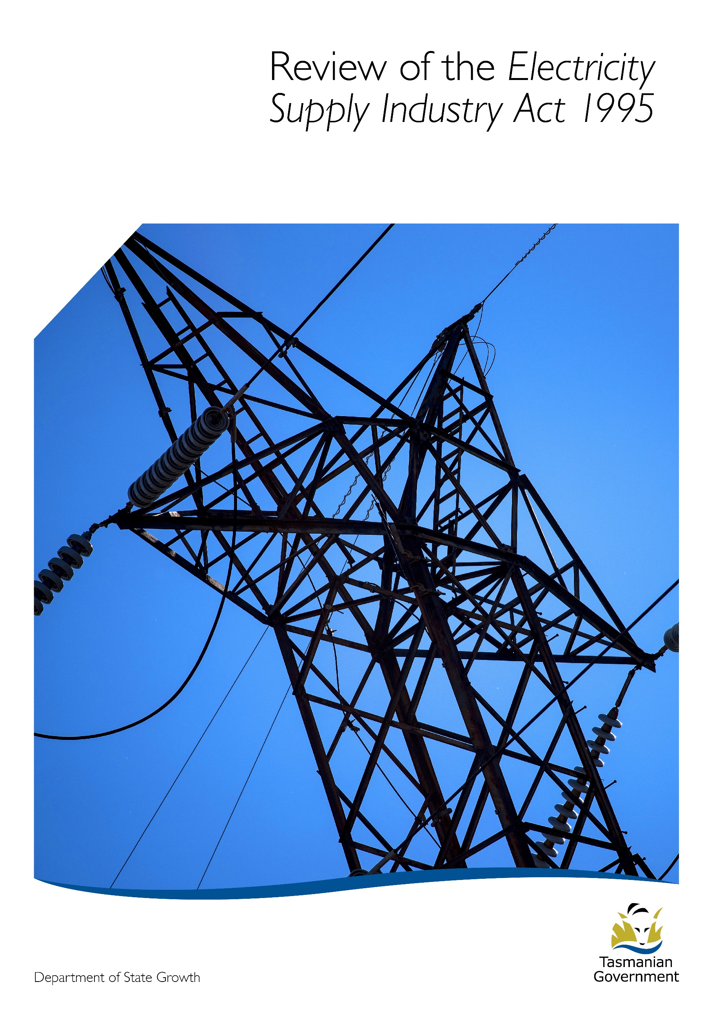
  - Consultation Summary

Background
The Tasmanian Government is committed to delivering a secure and reliable electricity supply with the lowest possible power prices. Key outcomes of Government policy are improving the efficiency of the electricity supply industry in Tasmania to ensure Tasmanians are getting the most reliable and affordable energy sector possible, as well as securing maximum opportunities for growth. This was a key theme in the Government’s energy strategy released in May 2015 – “Restoring Tasmania’s Energy Advantage” – and will continue to be a key theme in the Tasmanian Energy Plan.
As part of the strategy, the Department of State Growth, and the departments of Treasury and Finance and Justice have been tasked with reviewing the Electricity Supply Industry Act 1995 (ESI Act). The review will consider the ESI Act in the context of changing technologies and the national transition to a lower emissions generation sector to ensure that the legislative arrangements remain fit for purpose, and reflect a contemporary approach so that it delivers on reliability and price, thereby meeting the needs of customers and the community.
Electricity Supply Industry Act 1995
The Electricity Supply Industry Act 1995 (ESI Act) aims to promote efficiency and competition in the electricity supply industry, and to provide for a safe and efficient system of electricity generation, transmission, distribution and supply.
The ESI Act was introduced following the Council of Australian Governments (COAG) national competition reforms aimed at developing a competitive national electricity market with greater customer choice and improved services.
The ESI Act provided a new economic and regulatory framework for the electricity supply industry, following the disaggregation of the Hydro-Electric Commission (HEC) into three businesses, and the removal of the monopoly held by the HEC for electricity generation in Tasmania. It set out the statutory arrangements for generation, transmission, distribution and supply of electricity, as well as wholesale electricity pricing, contracts and licensing within the industry.
The Act also provides for land use planning, rights of access, responsibility for electricity infrastructure, the role of electricity officers and their powers, arrangement for emergency restrictions, and enforcement powers.
Three Departments - State Growth, Treasury and Justice - have responsibility for separate areas of the ESI Act (including all subordinate instruments). The Department of State Growth has primary responsibility for administering the ESI Act and is leading the review of the ESI Act. A Working Group made up of State Growth, Treasury and Justice Officers has been established to ensure coordination with all three areas of the Act that are under review by the relevant Departments.
The Department of Justice intends to remove its responsibilities from the ESI Act and consolidate these into a new Electricity Safety Bill. The new Electricity Safety Bill is designed to prevent electrical accidents and injuries, promote good practice in the design, use and maintenance of electrical systems and consolidate electrical safety requirements currently spread over three Acts.
Within the ESI Act the Treasurer has primary responsibility for price regulation and market design, including the establishment of the Regulator. Treasury has advised that given the current review into the wholesale electricity price framework, which will impact on the legislative requirements in setting regulated tariffs, it is not prudent to review these provisions of the Act at this time.
Therefore this review excludes those provisions for which the Treasurer is responsible. These provisions will be considered by Treasury following the completion of the review into the wholesale electricity price framework. The outcome of the review is expected to occur in the first quarter of 2020 at which time Treasury will provide advice to the Government.
Purpose of the current review
The background to, and purpose, of the review were outlined in the Discussion Paper, released on 26 July, 2019. As noted in that paper, this review will not revisit issues raised during 2014-15 in the development of the Strategy, or structural competition issues reviewed previously by the Tasmanian Electricity Supply Industry Expert Panel.
Consultation-Key issues raised by stakeholders
A discussion paper was posted on State Growth’s website on 26 July, 2019 and stakeholders invited to provide submissions, with this initial round of consultation ending on 23 August 2019. The Department of State Growth received 8 written submissions including those from the State’s energy businesses (see Attachment A). Copies of the consultation responses can viewed on the ESI consultation page of the Department of State Growth’s website. [insert weblink]
Stakeholders who responded to the consultation raised a variety of issues. A summary of the key headline issues and themes raised respondents are listed below:
There are targeted opportunities to improve the effectiveness of the ESI Act by:
- Repealing or amending outdated provisions. A number of stakeholders identified specific areas of the Act.
- Reviewing the ESI Act to remove areas of residual regulatory duplication between the Office of Tasmanian Economic Regulator and the Australian Energy Regulator.
Ensuring the new Act recognises and accommodates changes in technology and innovation in the energy market
- There is a need to modernise the operations of the ESI Act, particularly those aspects related to changes in technology and changed market roles such as 2017 Power of Choice National Energy Market rule changes.
- There has been considerable change in the electricity market since the ESI Act was initially drafted. New technology changes are occurring that will allow energy customers greater options in relation to how they interact with the electricity network and markets. Therefore changes in legislation will be required to enable customers to make the most of these opportunities.
- The changing nature of the electricity network, for example through increased numbers of customers using Stand Alone Power Systems (SAPS) will require an agile and innovative response to meet customer needs. The review presents an opportunity to ensure legislative arrangements are flexible enough to meet future needs.
Ensuring Energy businesses have the statutory and legislative underpinning to carry out their operations
- The role of Metering Coordinator needs to be recognised in the legislation.
- Land access – the ability of energy entities to access private land to inspect/maintain electrical assets on private property needs enhanced statutory underpinning.
- A New Act should provide TasNetworks with a clear legislative basis and statutory rights to perform inspections of private electrical infrastructure.
Other issues raised by stakeholders
- Land acquisition powers – one respondent stated that the Act needs to be amended so that it is specified that only publically owned electrical entities are able to acquire land for electricity infrastructure.
- The new electricity Act should specify that new renewable energy projects (in particular windfarms) should use existing infrastructure and collocate where possible and avoid public reserved lands for construction/acquisition.
- A New Act must be able to be flexible enough to take into account current and future changes in technology.
- Overall the ESI Act functions adequately in articulating and supporting Tasmania’s electricity market. There is no major market failure associated with the ESI Act.
Next steps
The ESI Working Group is considering the submissions received from stakeholders. The Department of State Growth will continue to undertake targeted consultation with key stakeholders which will include generators, network service providers, retailers, other market participants, consumer groups, and major energy consumers with direct market exposure. The Tasmanian Economic Regulator, the national market bodies, other Tasmanian Government agencies, and other parties will also be consulted as appropriate.
Once considered by the Government proposed changes to the ESI Act and a draft Bill will be subject to a period of further consultation with market participants and relevant stakeholders to obtain views and comments in relation to the potential impact of any proposed changes, and to ensure that the implementation of these changes is as smooth as possible.

Attachment A

The following stakeholders provided written submissions to the consultation document:
- TasNetworks
- Aurora Energy
- Tasmanian Farmers and Graziers Association (TFGA)
- Highland Conservation Pty Ltd
- Mr John Thompson
- Dr Romy Greiner
- Energy Ombudsman
- Hydro Tasmania

Department of State Growth
GPO Box 536
HOBART TAS 7001 Australia
 | Phone: | 1800 030 688
 | Email: | esireview@stategrowth.tas.gov.au
 | Web: | www.stategrowth.tas.gov.au

